Scenario - 1: Verification of UG Course in KSG College

search for ksg webisite in google <https://www.ksgcollege.com/>

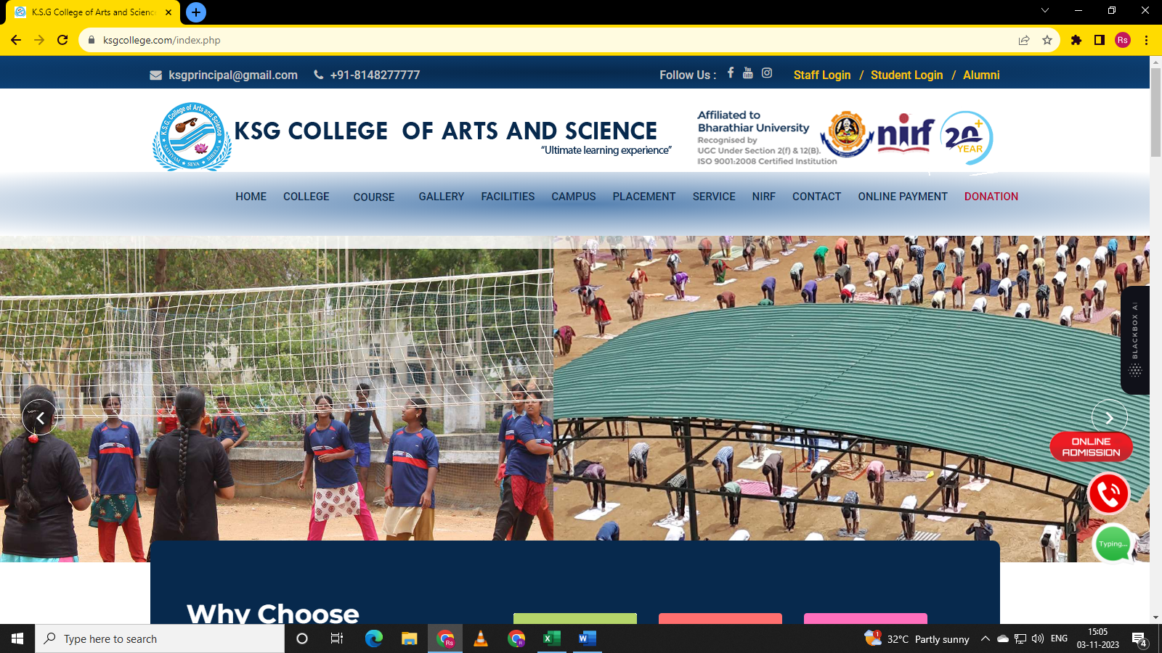

KSG website is displayed.

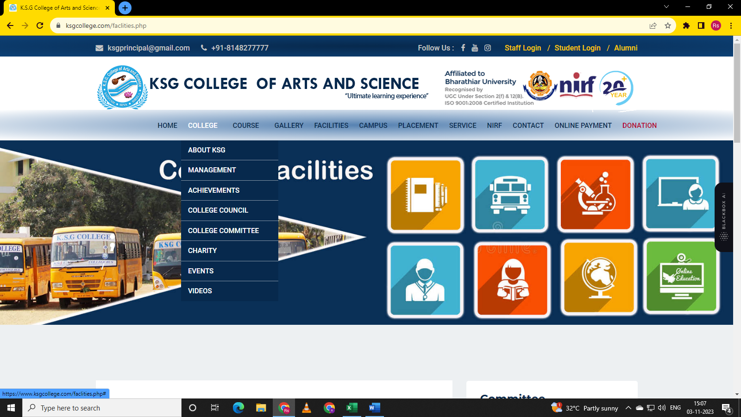

Navigate to College Module. College options - About KSG, management, Achievements, College Council, College Committee, Charity, Events, Videos should display.

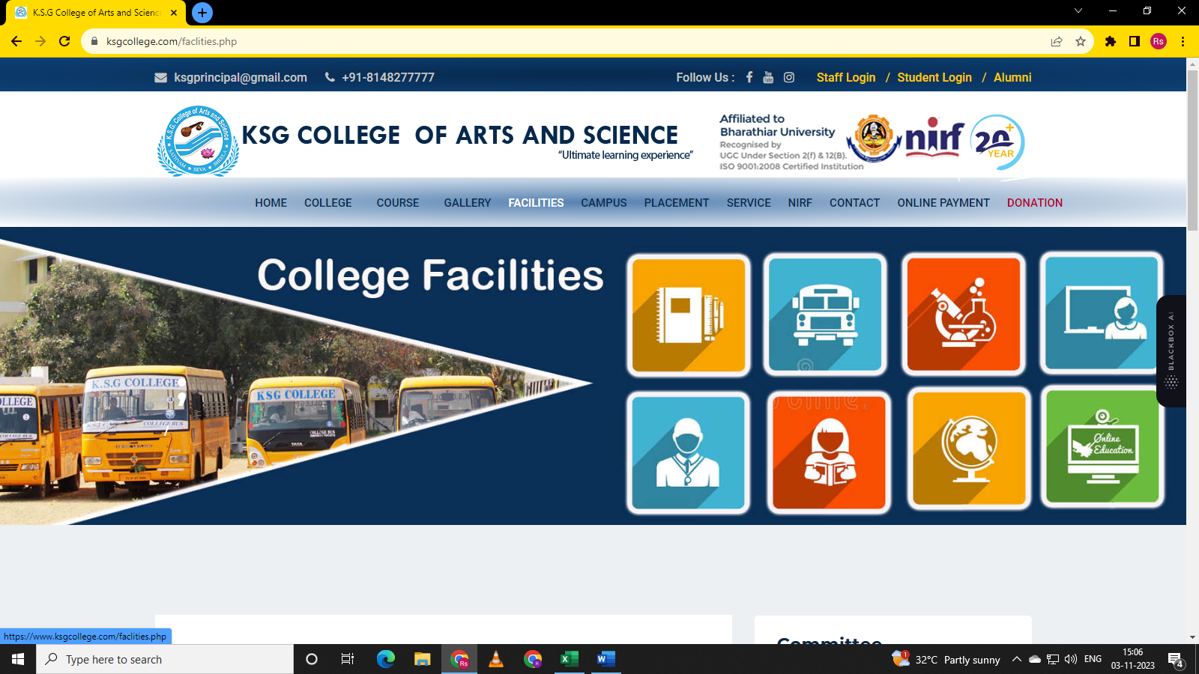

Navigate to course module

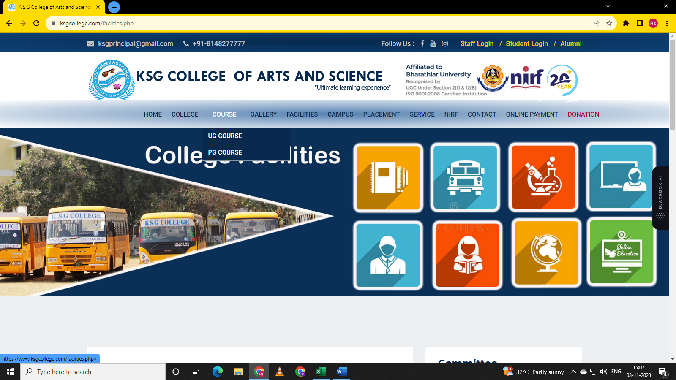

UG Course and PG Course are displayed.

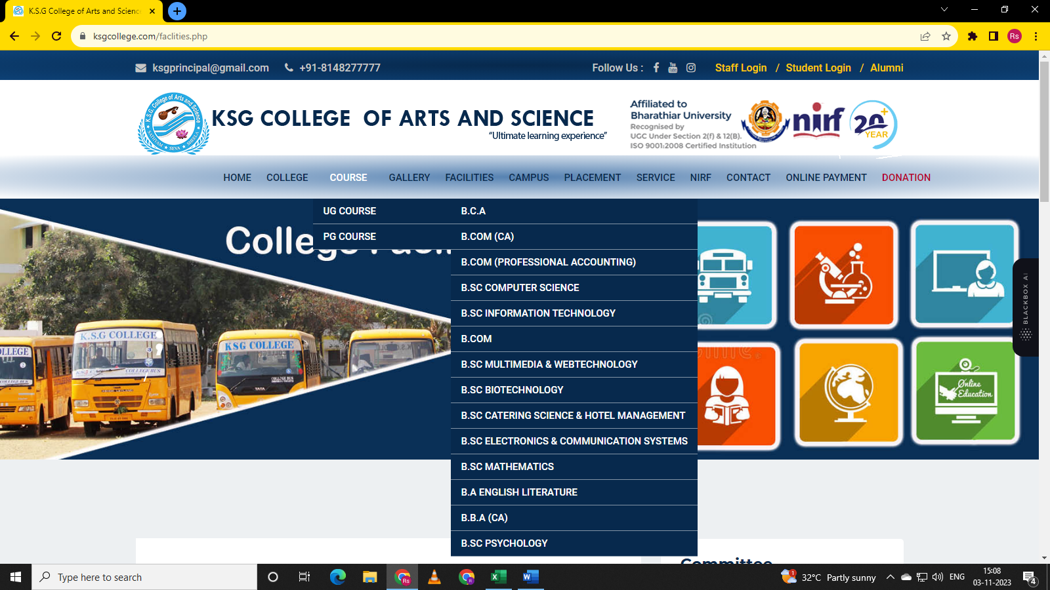

UG courses sub options are displayed.

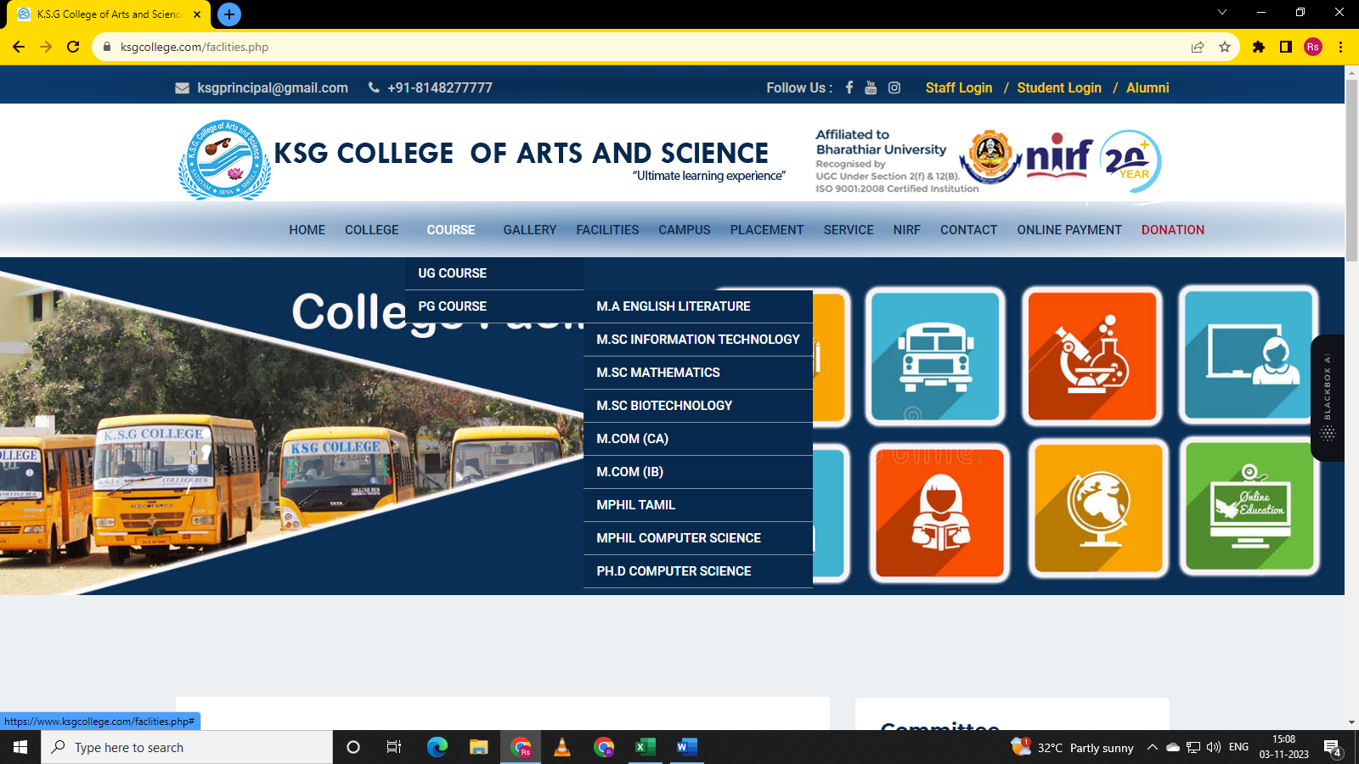

PG Courses Sub options are displayed.

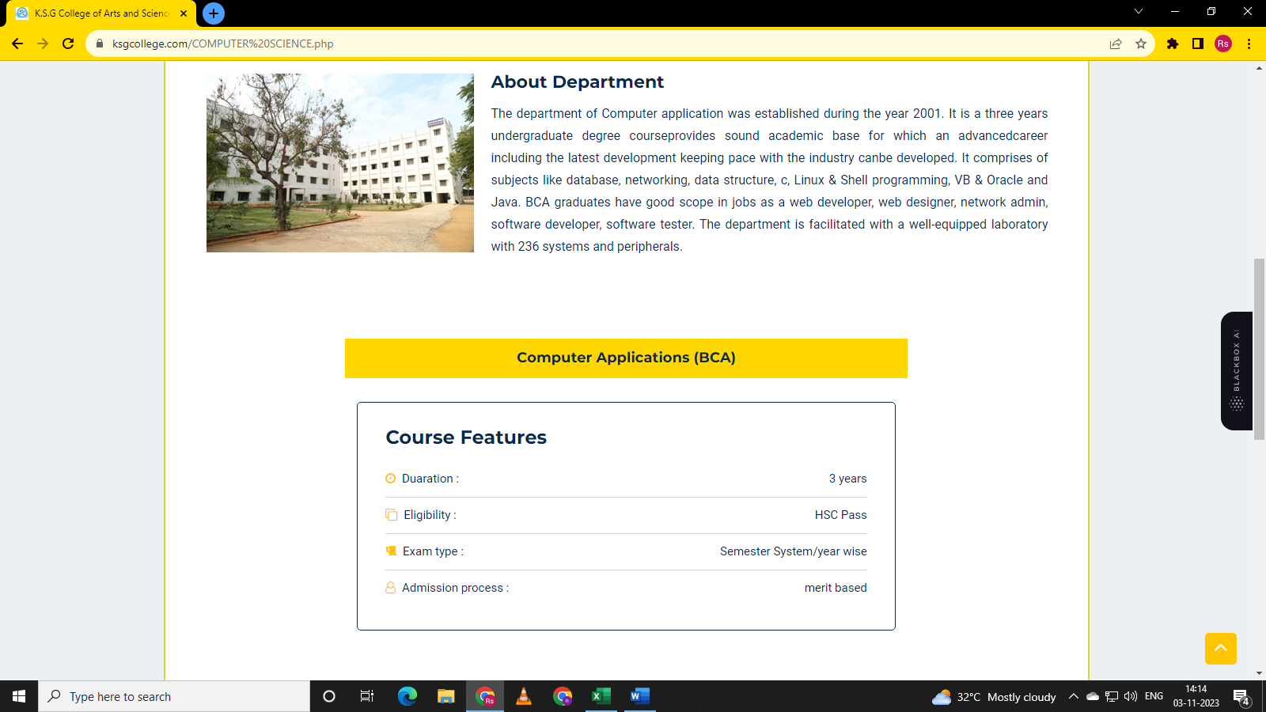

B.SC computer science heading is displayed but B.C.A course details are displayed.B.SC Computer science course need to display.



B.SC Information Technology heading is displayed but B.C.A course details are displayed. B.SC Information Technology course details not displayed.

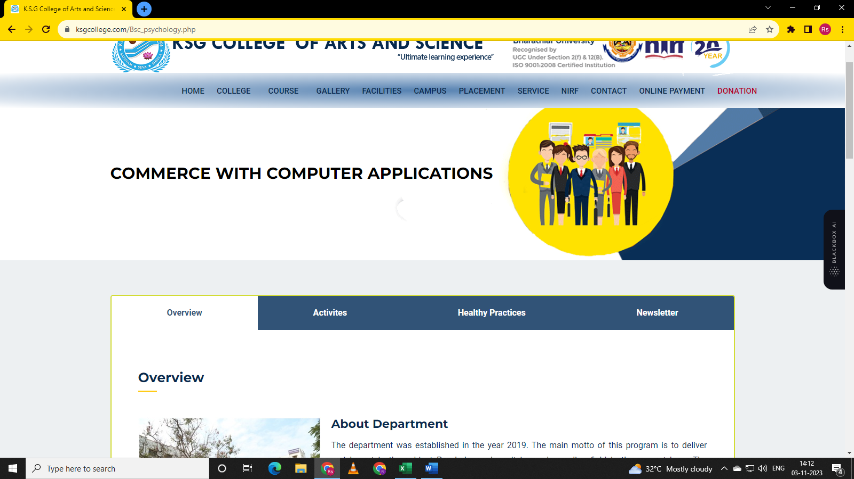

When click on B.sc Psychology its heading is not matched with expected.

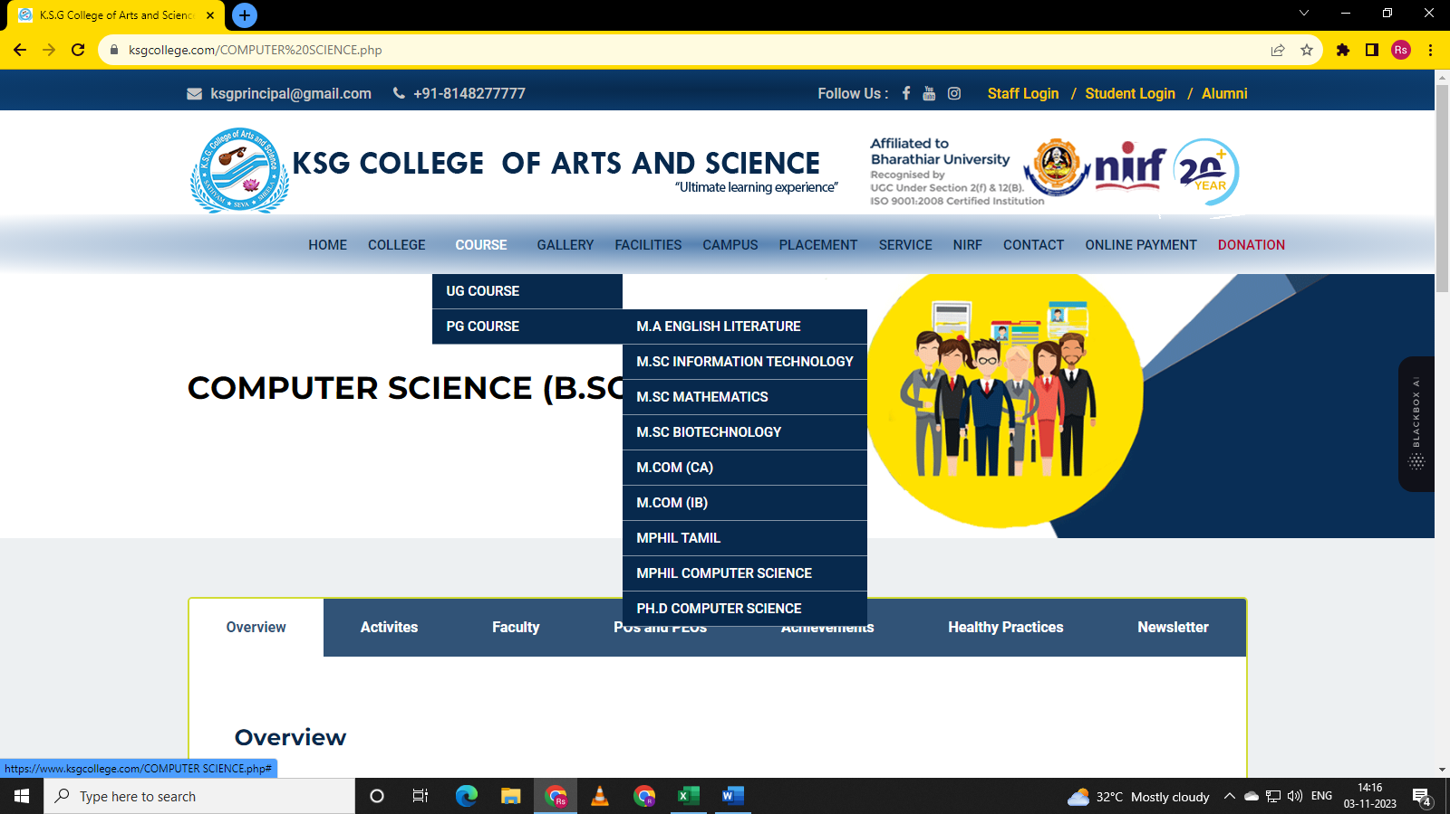

M A English Literature, M.SC Information Technology, M.sc Mathematics, M.SC Biotechnology, M.COM (CA), M.COM (IB), M. PHIL Tamil, MPHIL Computer Science, PH. D Computer Science. PH. D computer science. Every course selected one by one but its course details is not displayed.

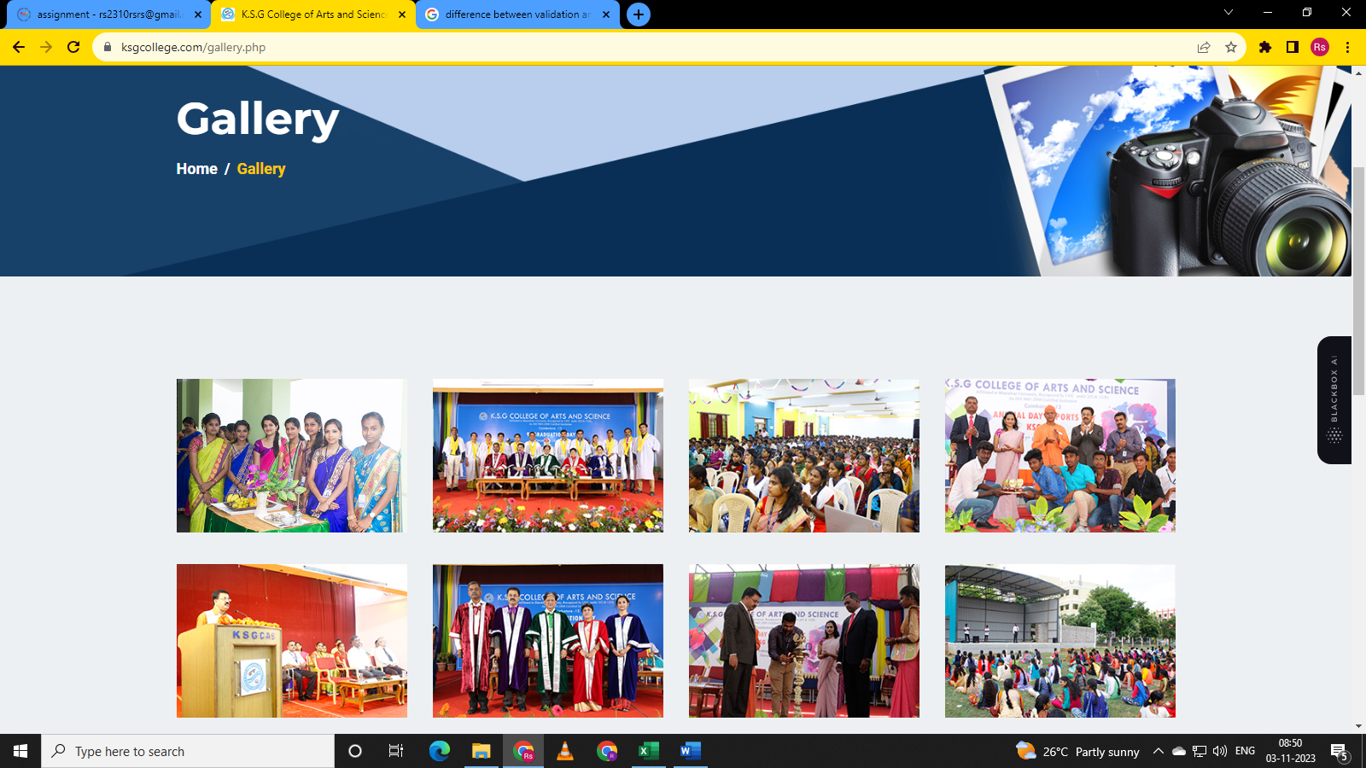

Gallery web page is displayed.

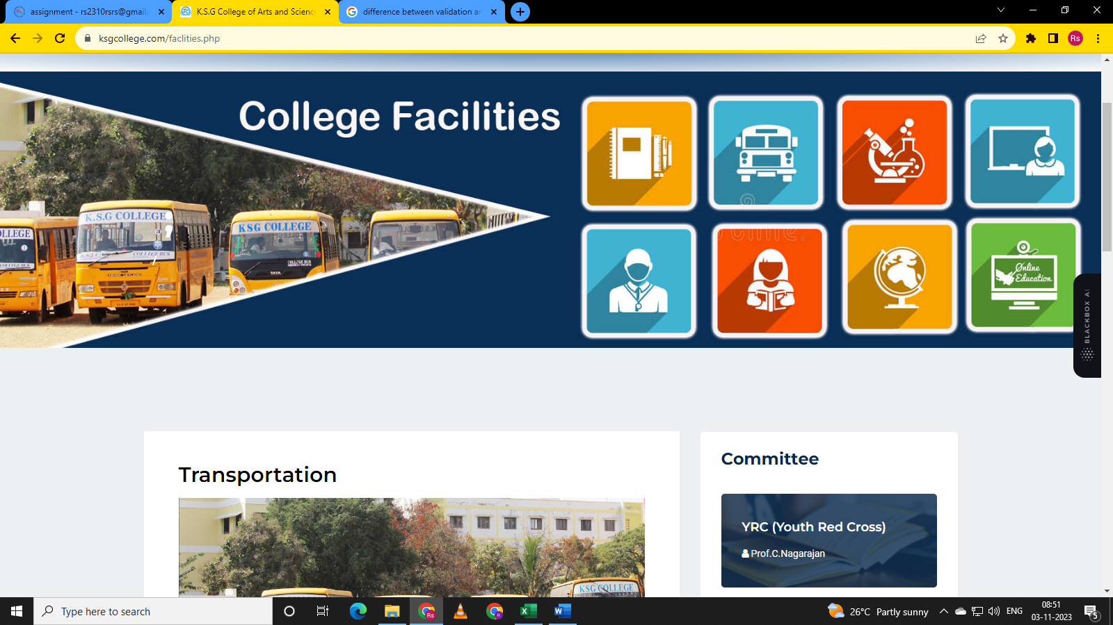

College Facilities web page displayed.

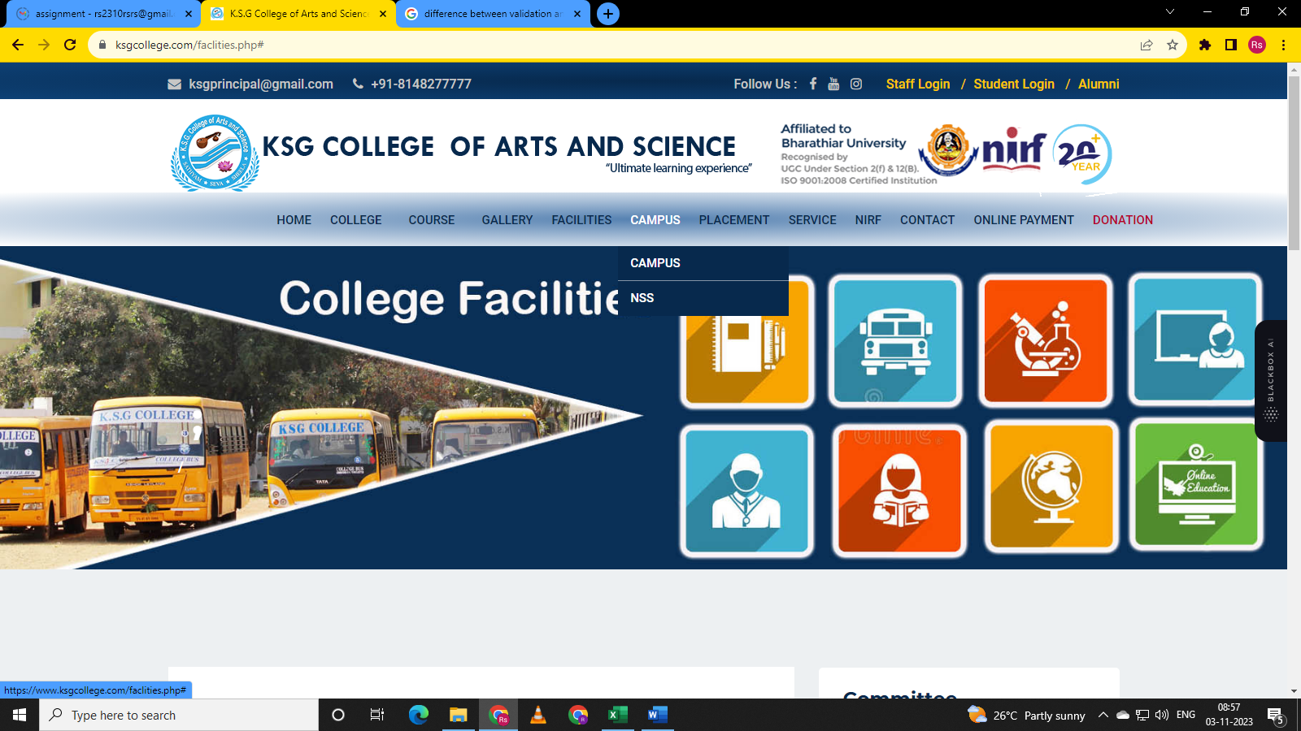

Navigate and hover on Campus Module. Campus and NSS options displayed

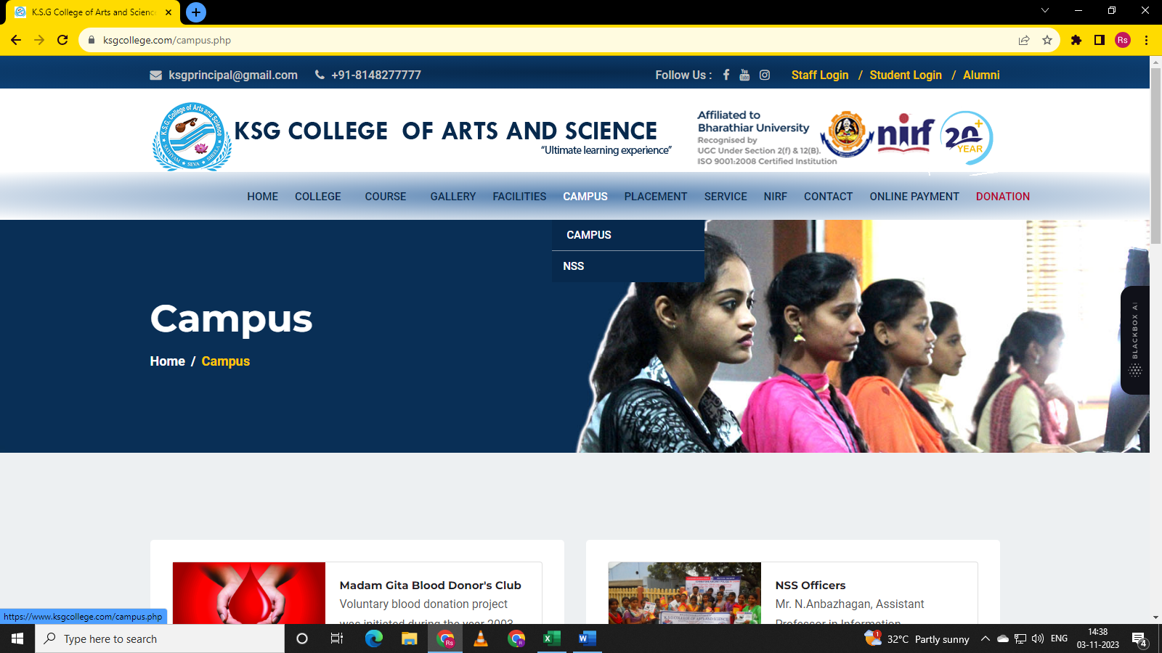

Campus page with its details is displayed.

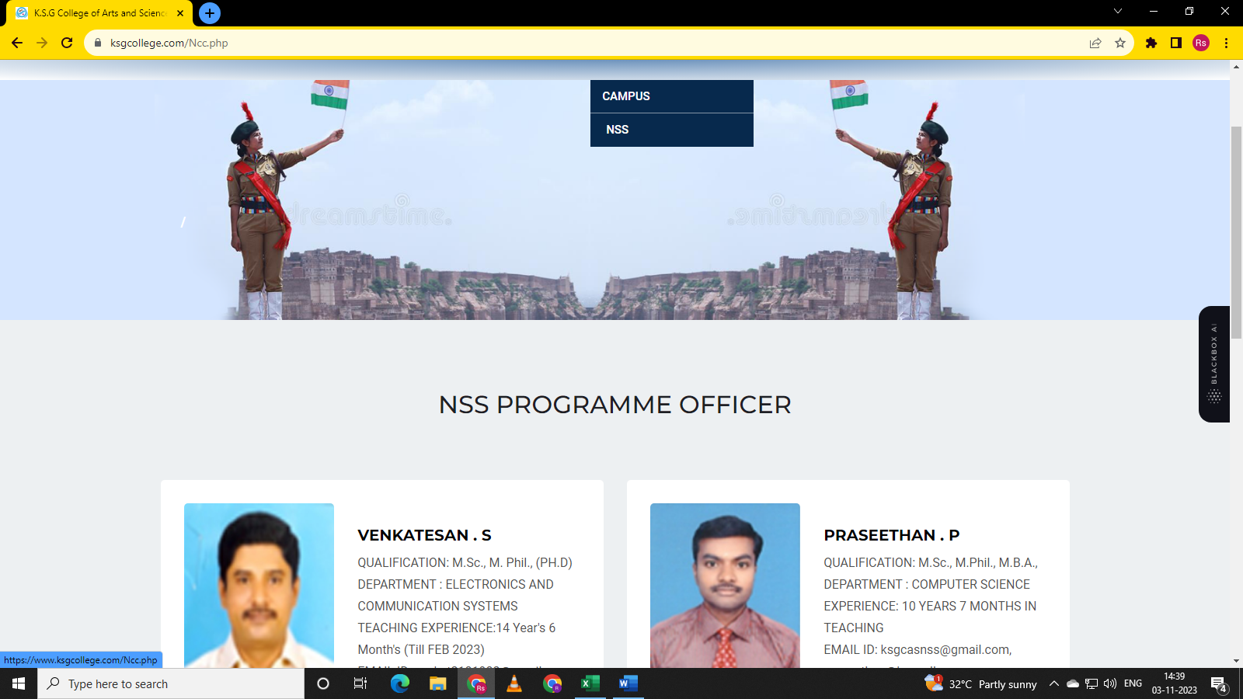

NSS page with its details is displayed.

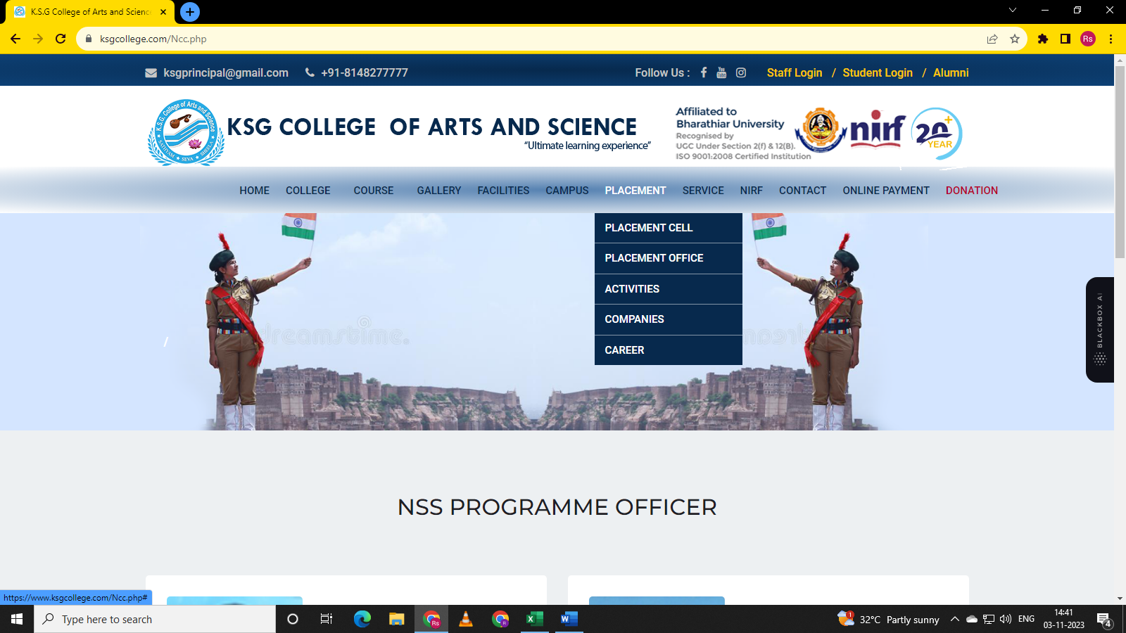

Navigate to Placement. Hover on Placement. Placement Cell, Placement Office, Activities, Companies, Career sub options is displayed.

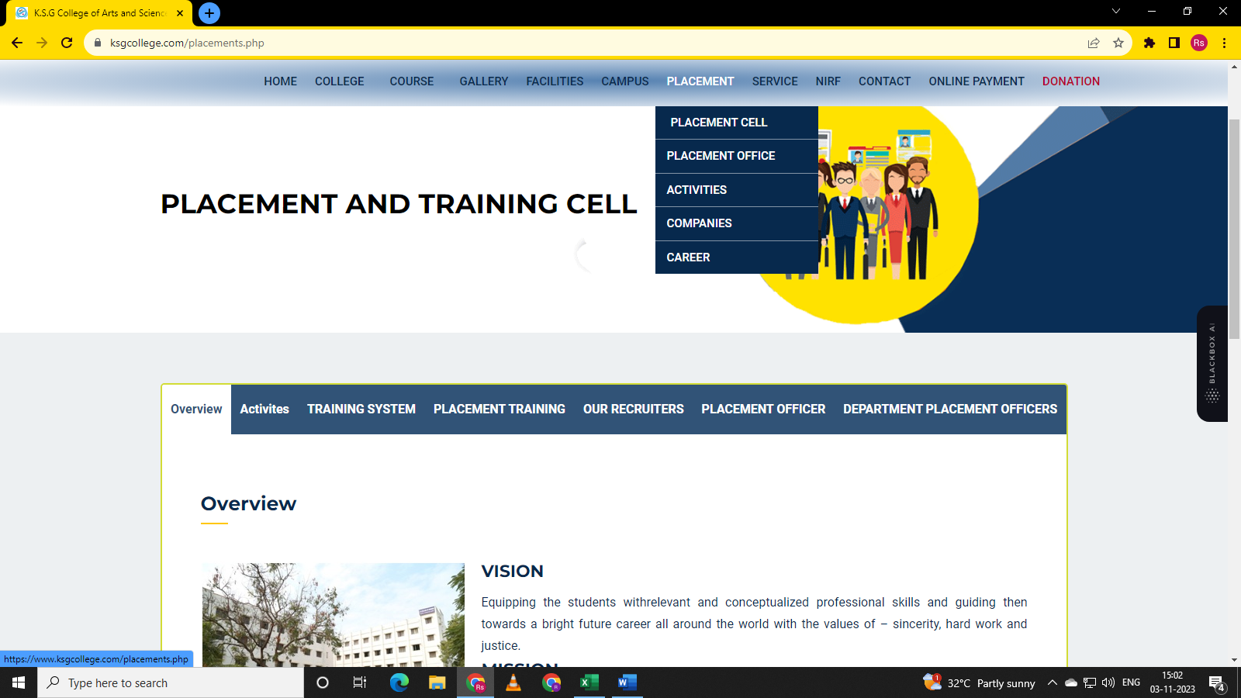

Placement Cell page with its details is displayed.

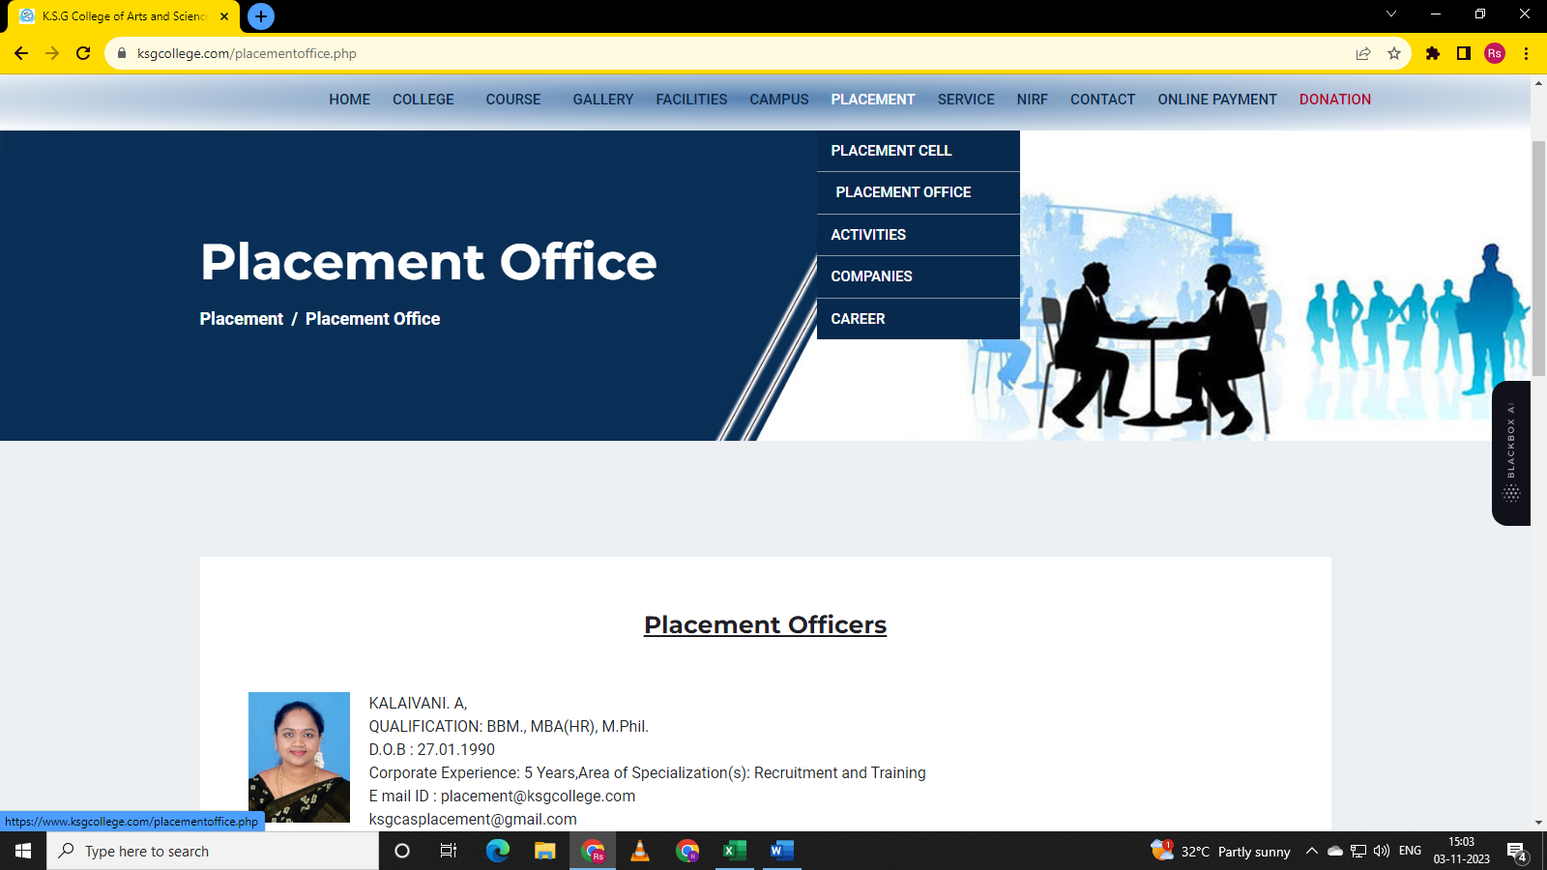

Placement Office page with its details is displayed.

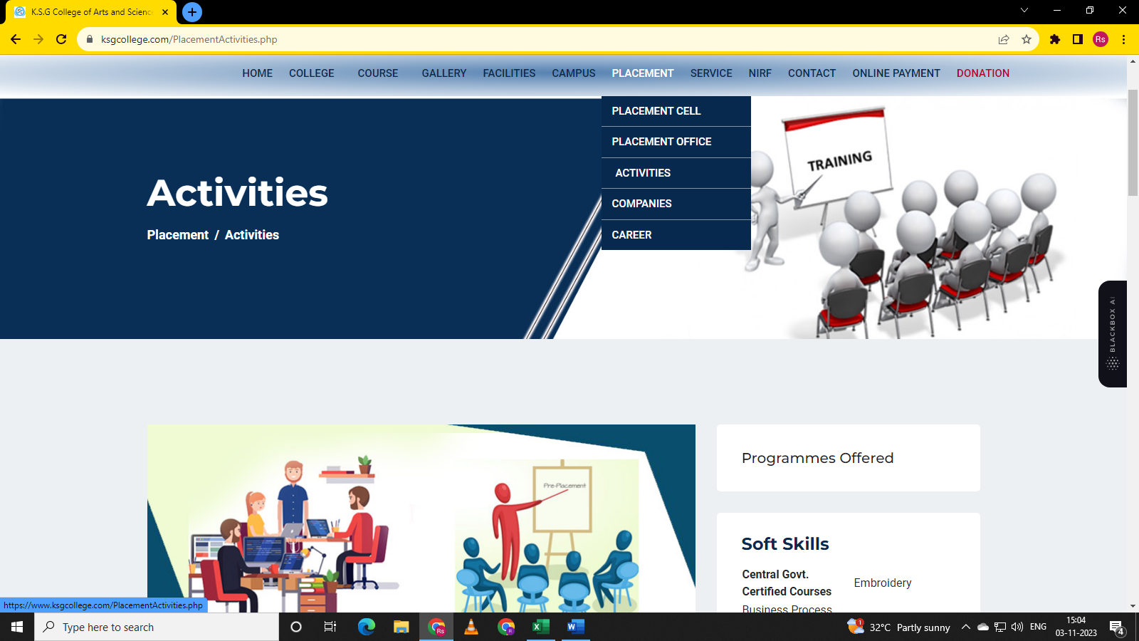

Activities page with its details s is displayed.



Companies page with its details is displayed.

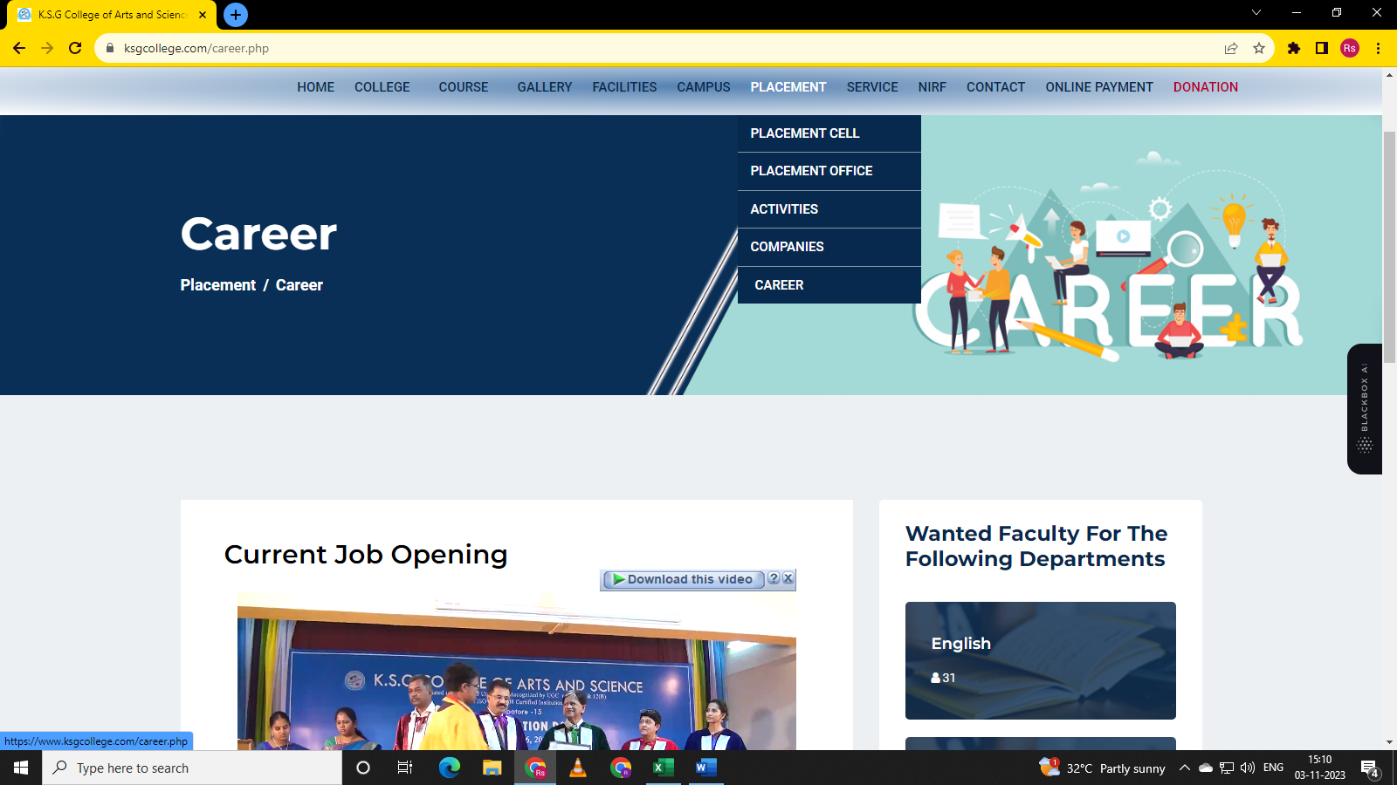

Careers Page with its details is displayed.

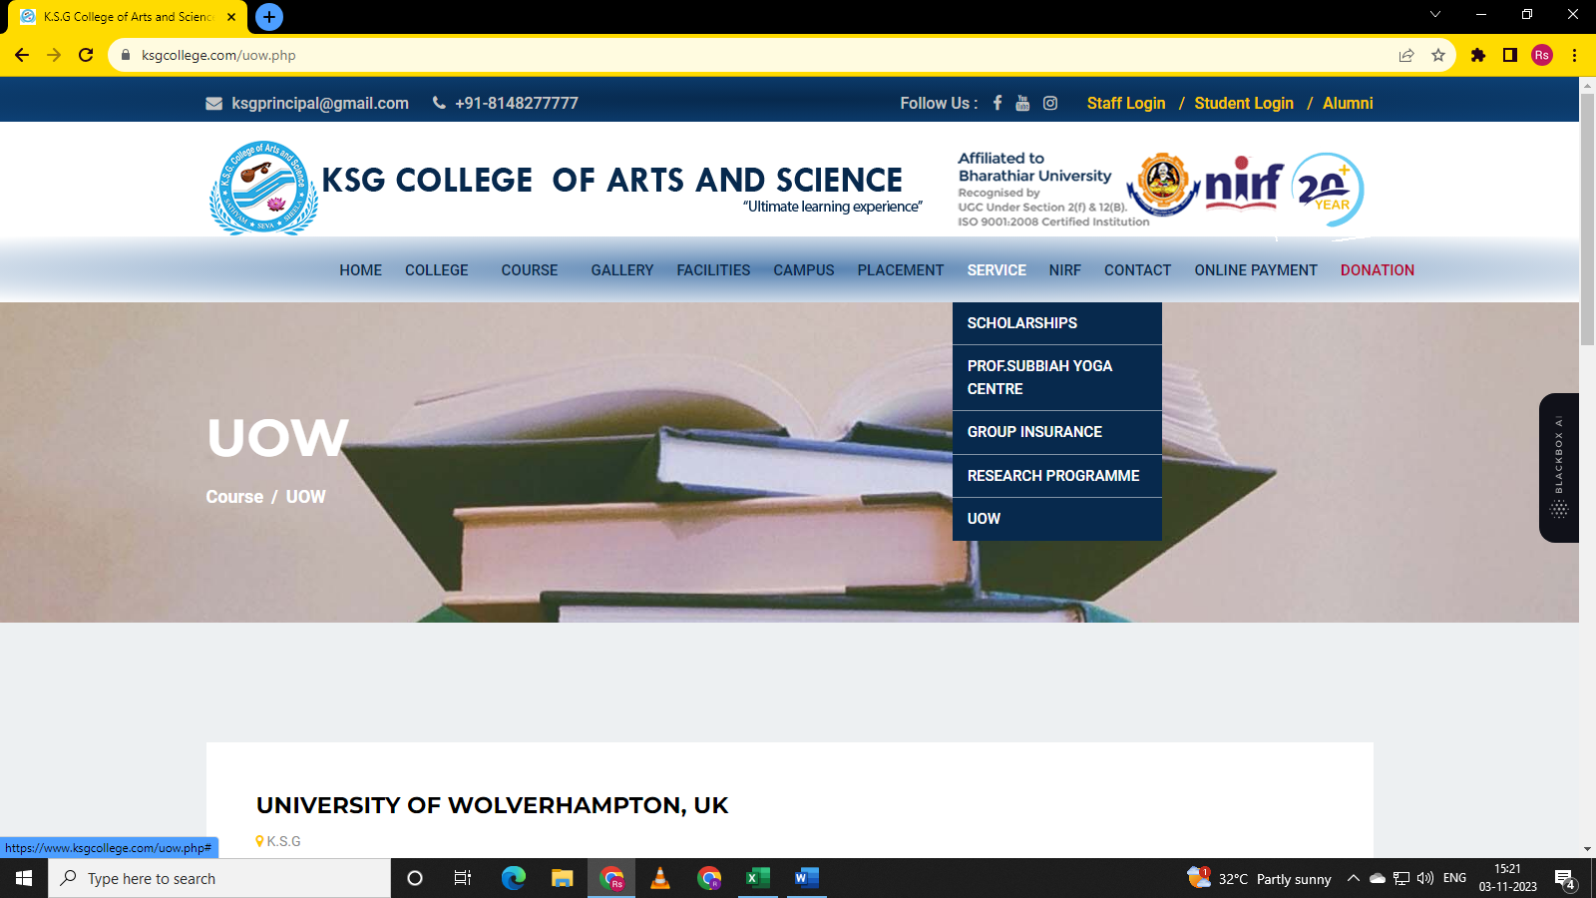

Navigate to Service. Hove on Service Module. Sub-options scholarships, Prof. Subbiah yoga Centre, Group Insurance, Research, UOW is displayed.

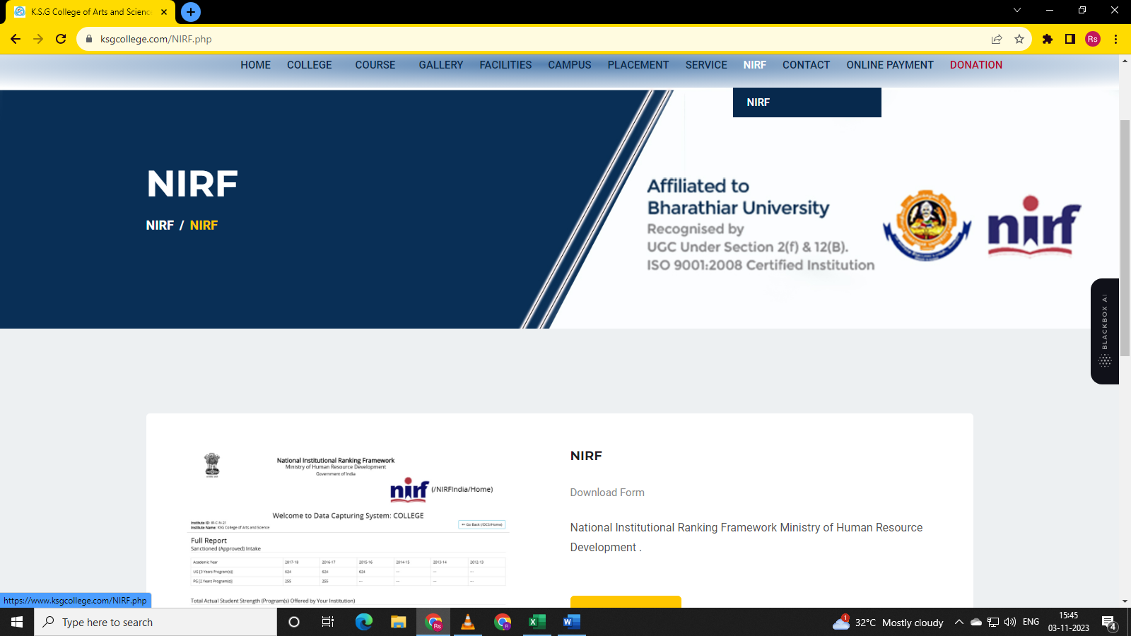

Navigate to NIRF module and select NIRF. NIRF page is displayed.

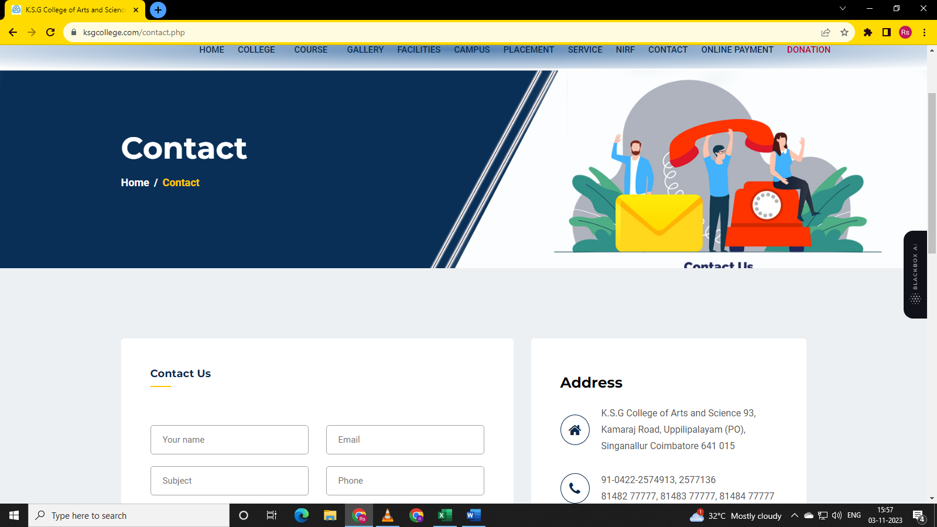

Navigate to Contact Module and click Contact. Contact page with its details is displayed.

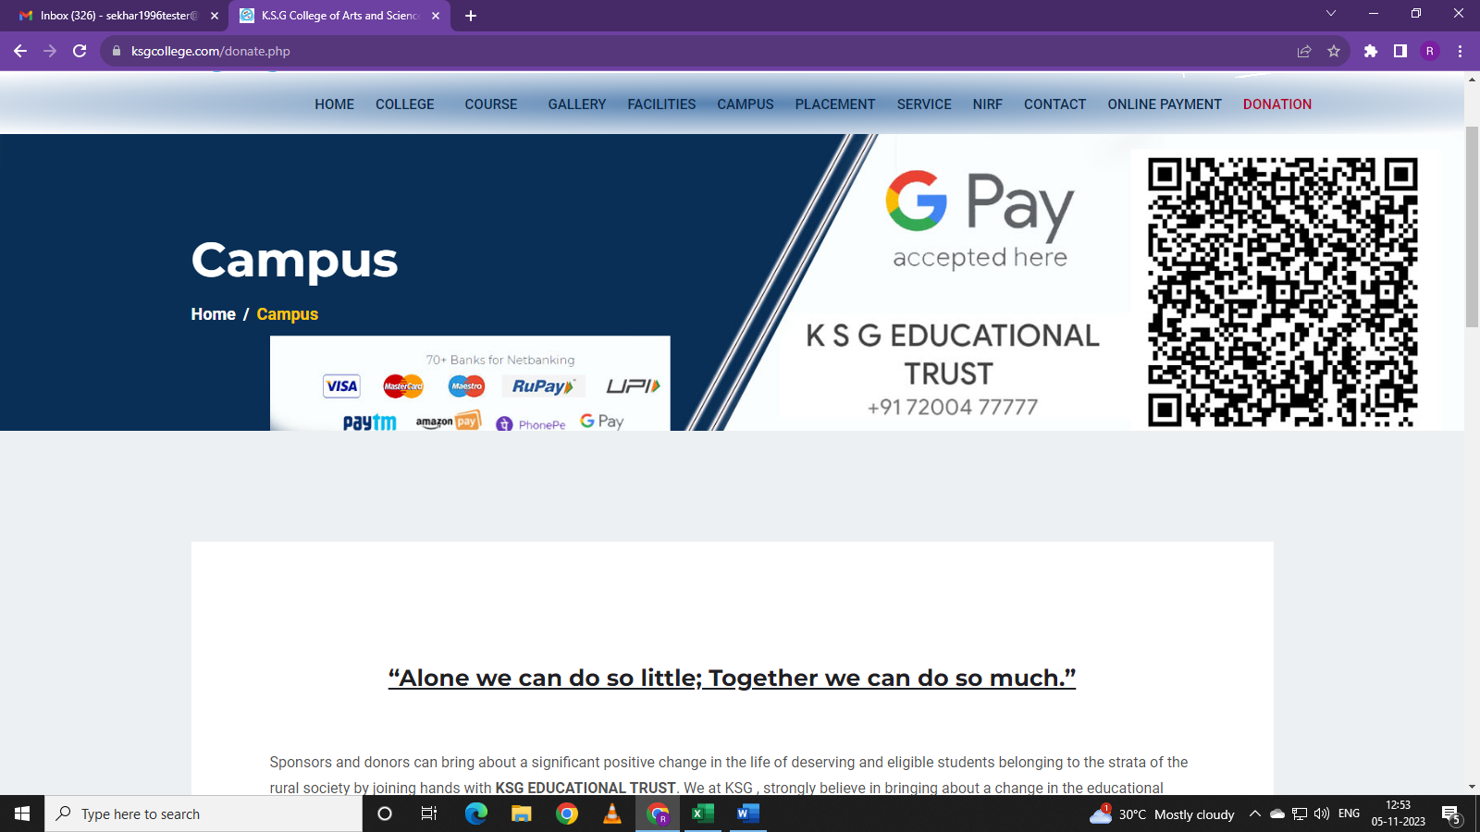

1.Navigate to Donation. 2. Click on Donation. Donation page with its details is displayed. But heading displayed is Campus instead of Donation.

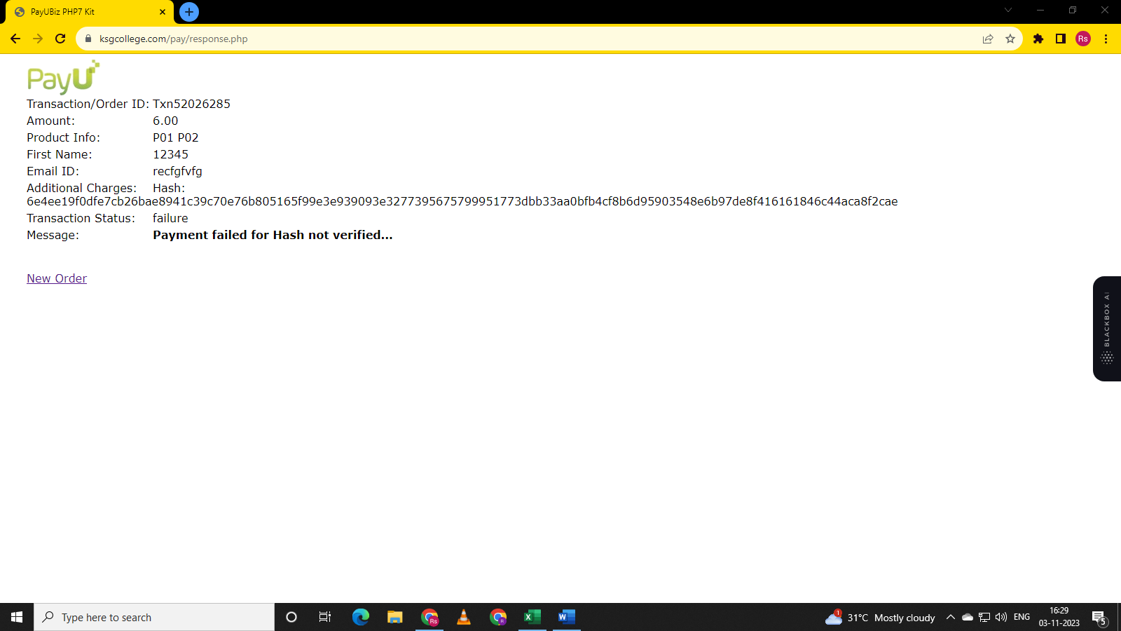

Navigate to online payment. Fill relevant details. Click pay. Name fields accepting numbers. Mail id field accepting any thing. It is not giving waring mail id entered is wrong.

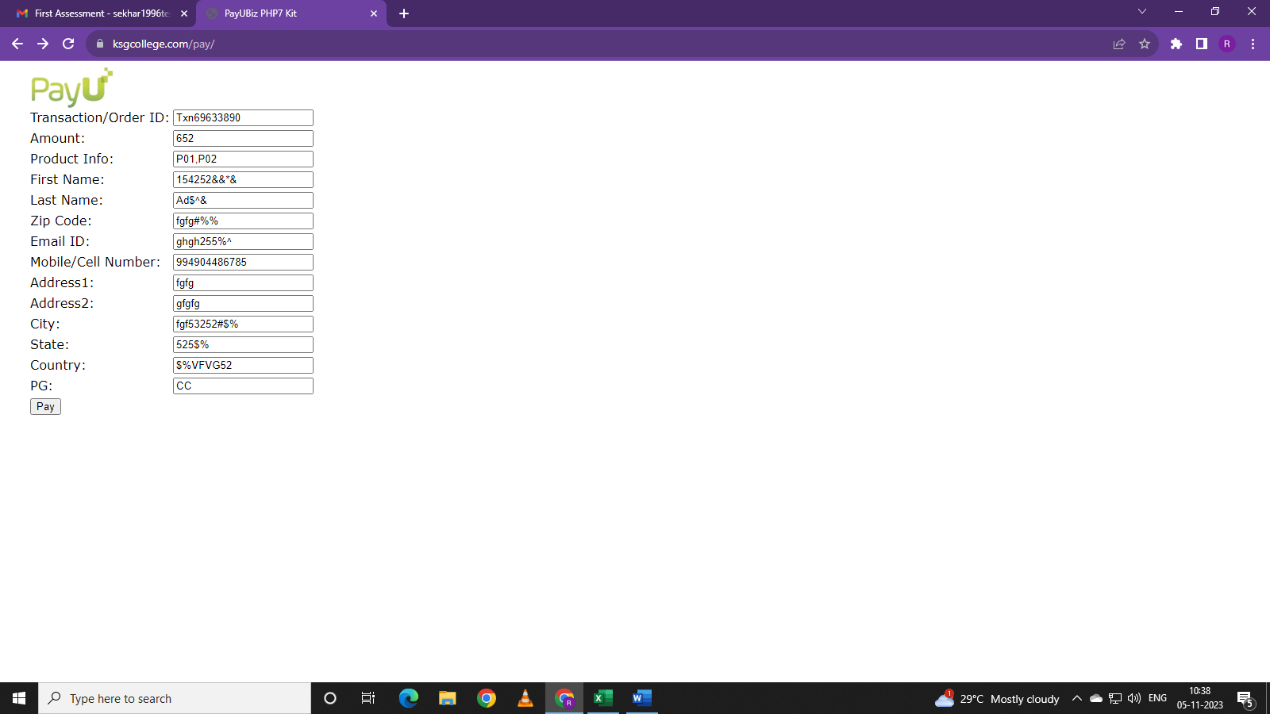

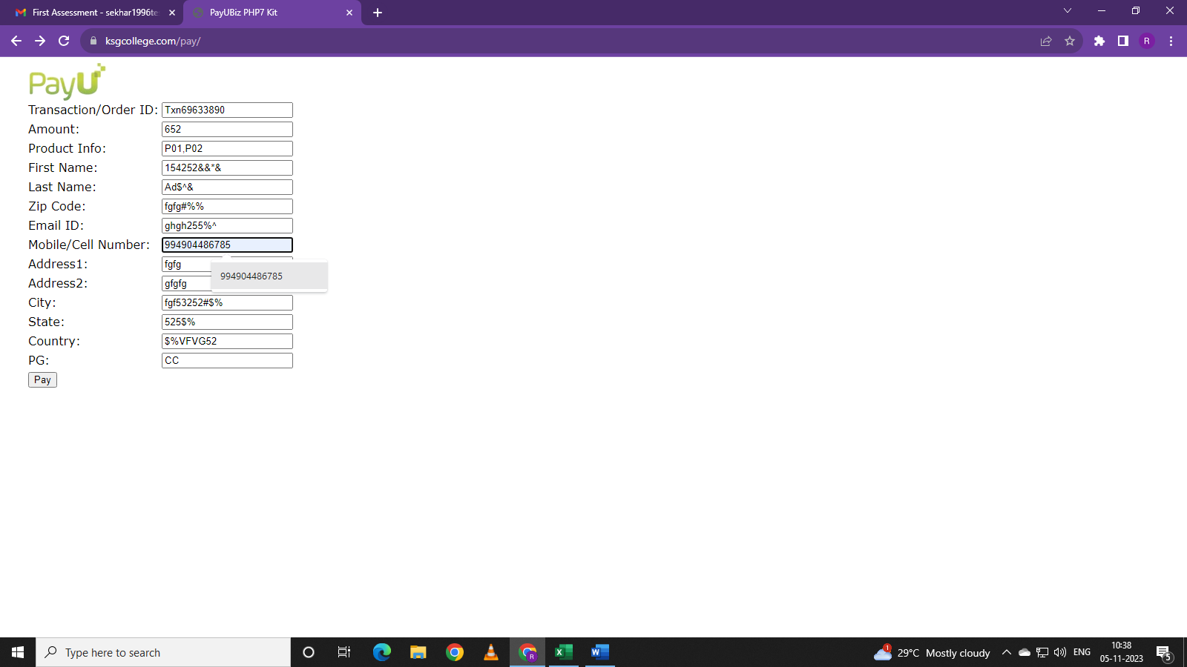

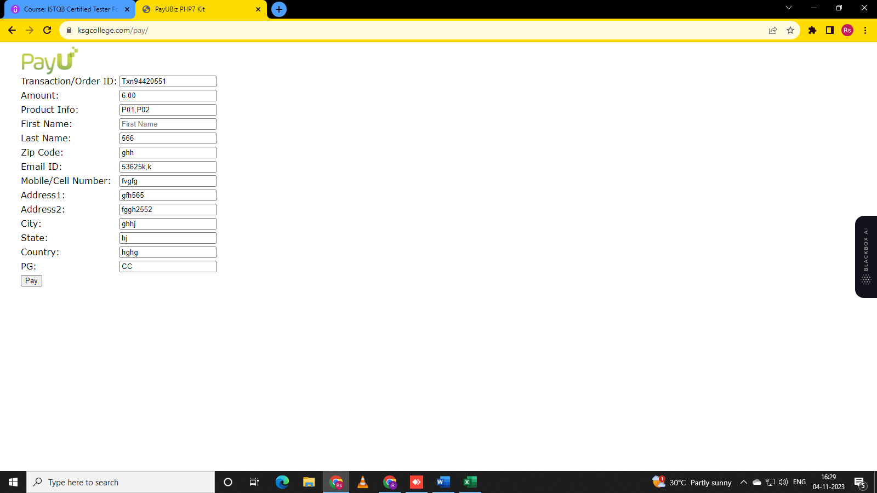

First name filed accept empty input also. Mobile number accept letters and cell numbers less than or greater than 10 digits.

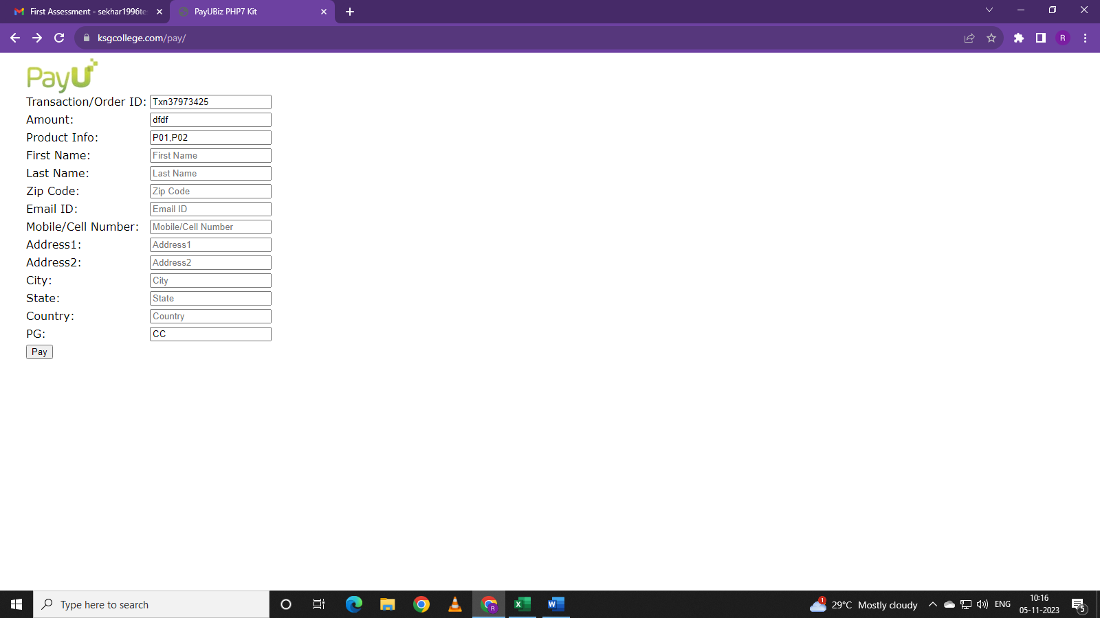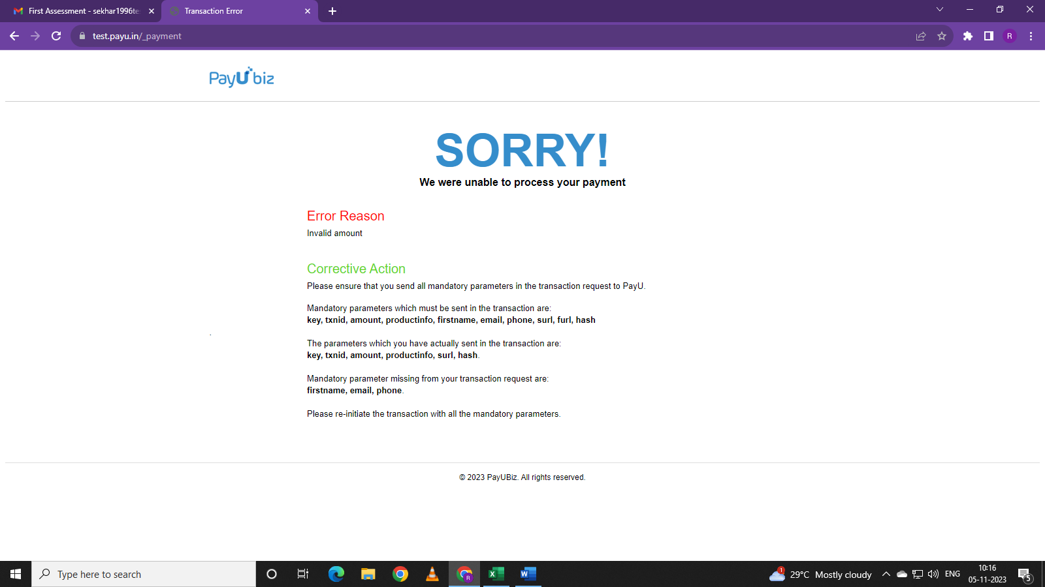

Amount Input showing error if we did not enter an amount or entered words or entered negative amount.

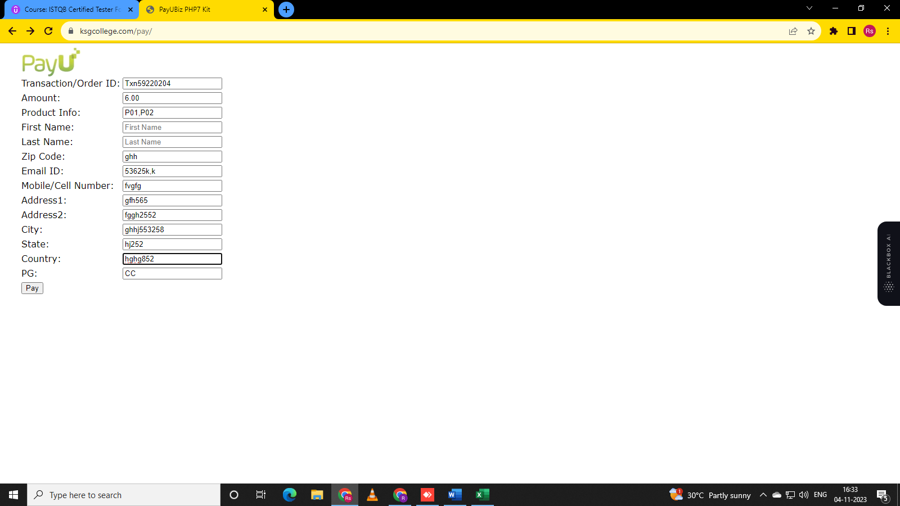

State and city field accepting numbers.

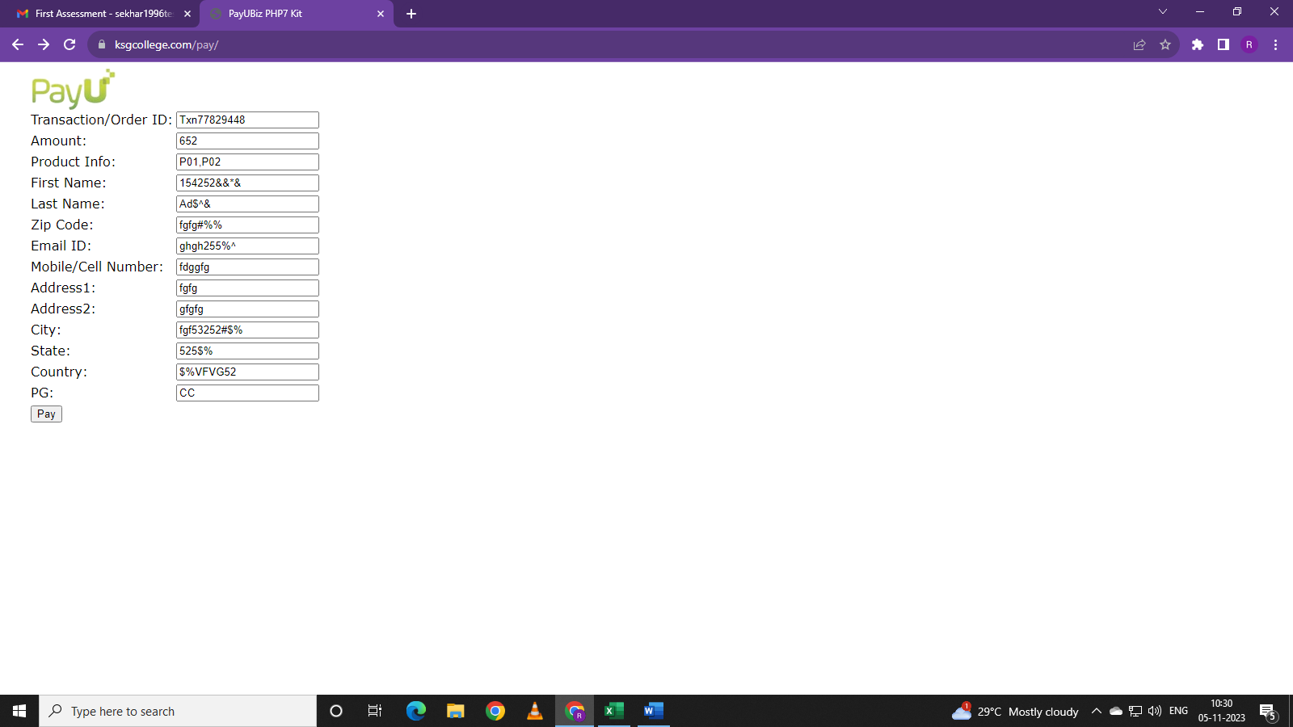

Expect amount, product Info, Transaction id, pg. Other inputs accepting Invalid inputs also.

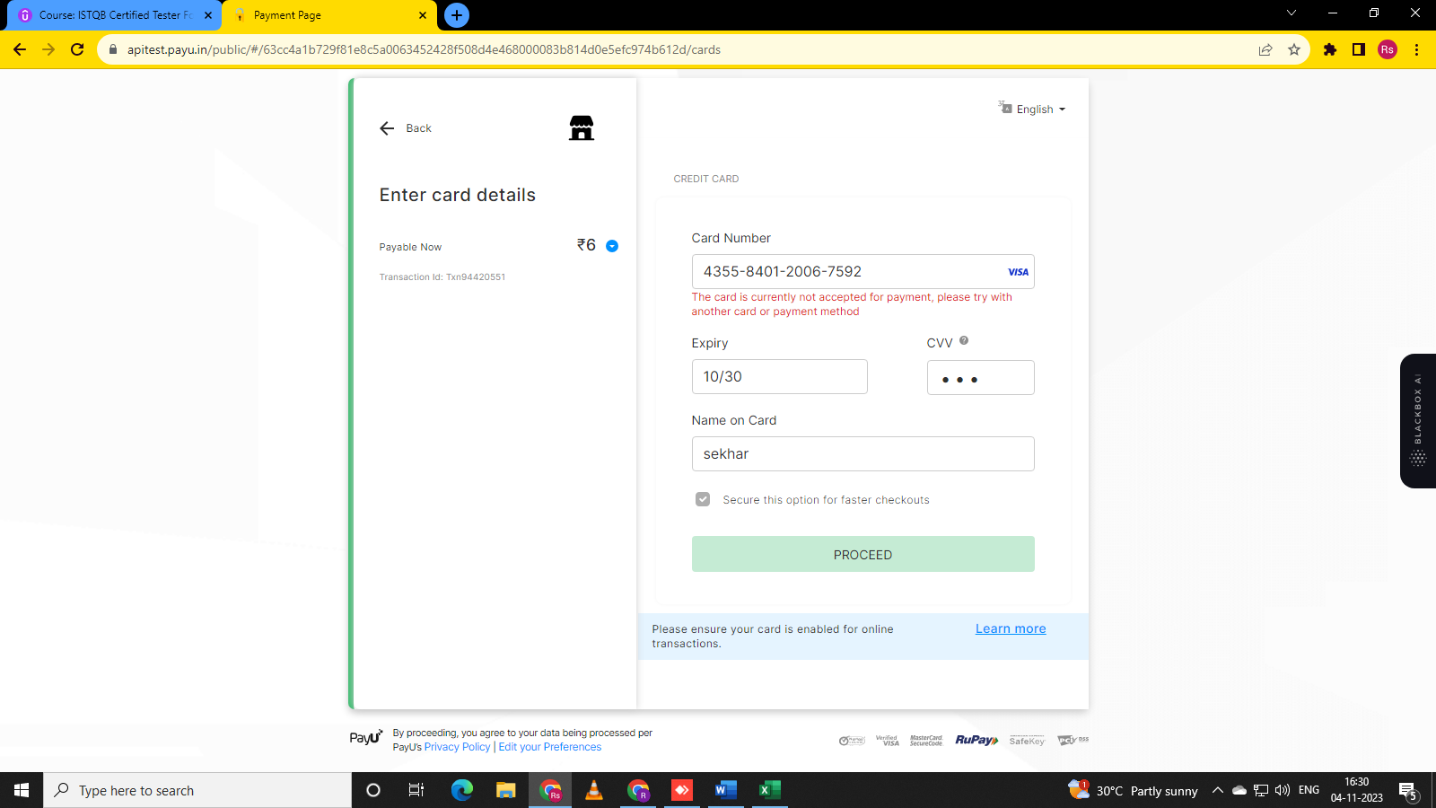

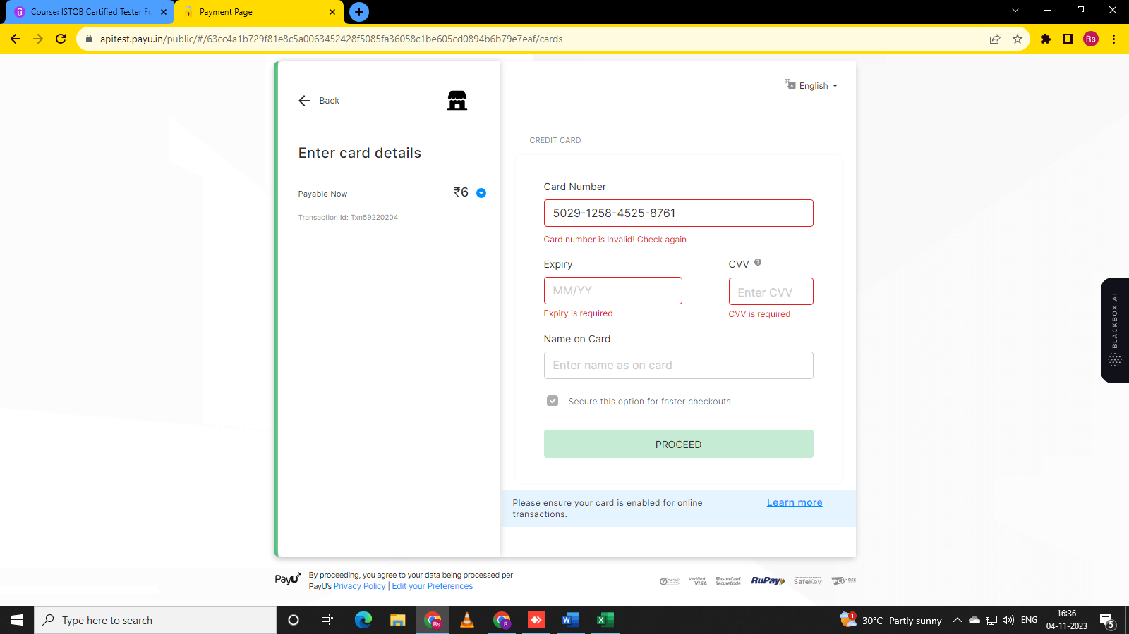

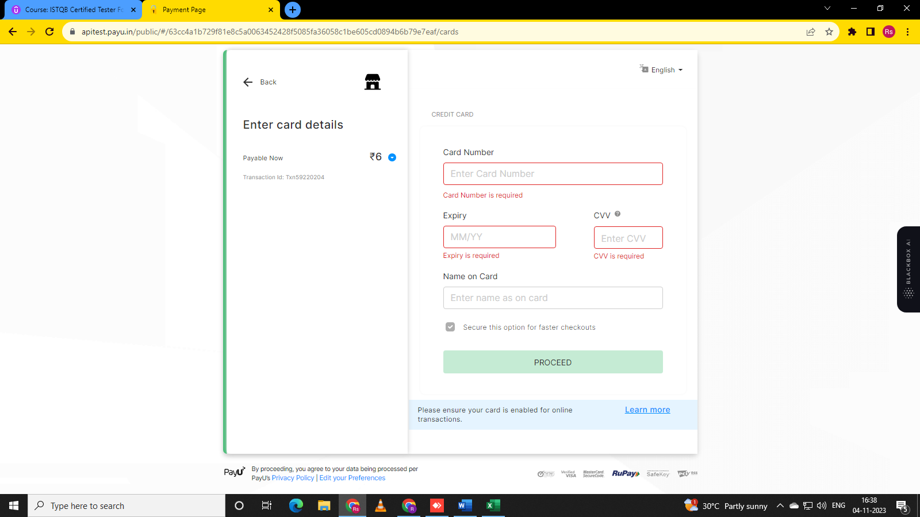

Card number and expiry and CVV fields gives warning if put empty. Expiry and CVV accepting only numbers.

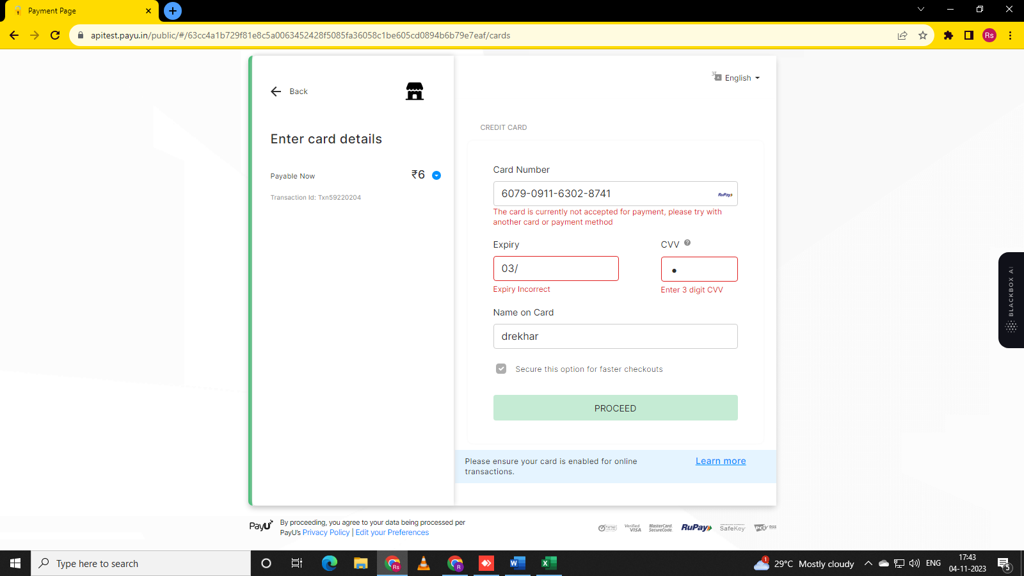

It gives warnings for card number, expiry date, CVV warnings.

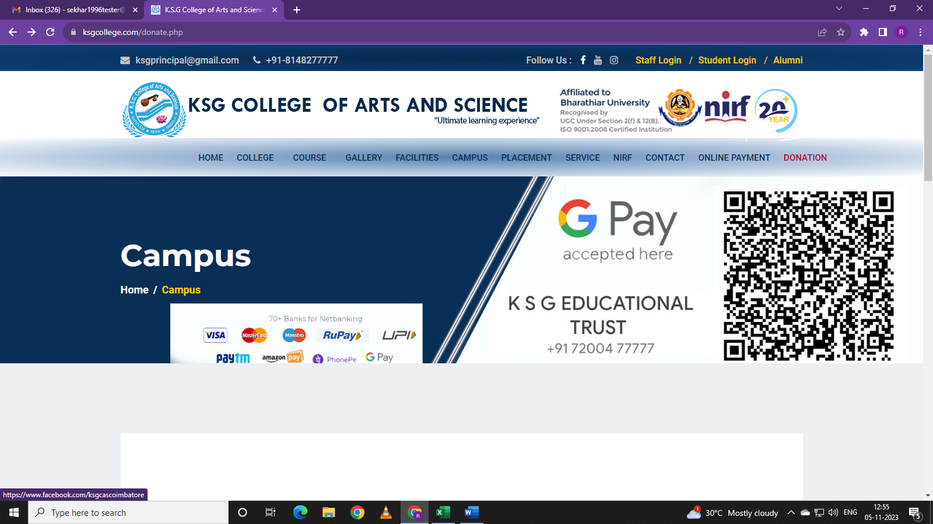

Navigate Follow Us (social media Icons) - Facebook, you tube, twitter. Select each option one by one.

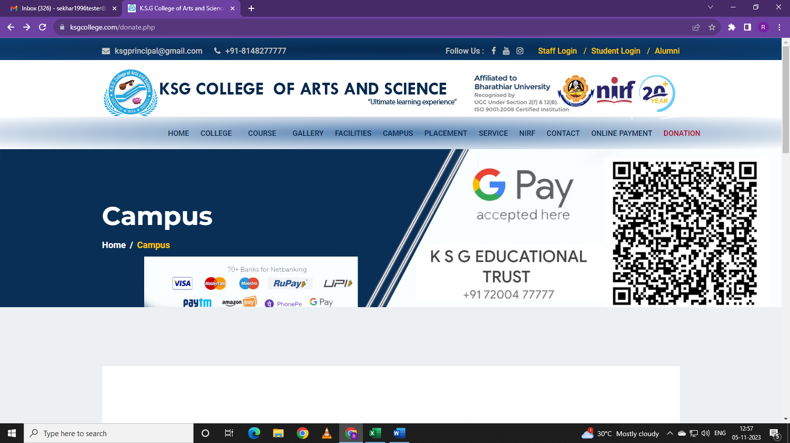

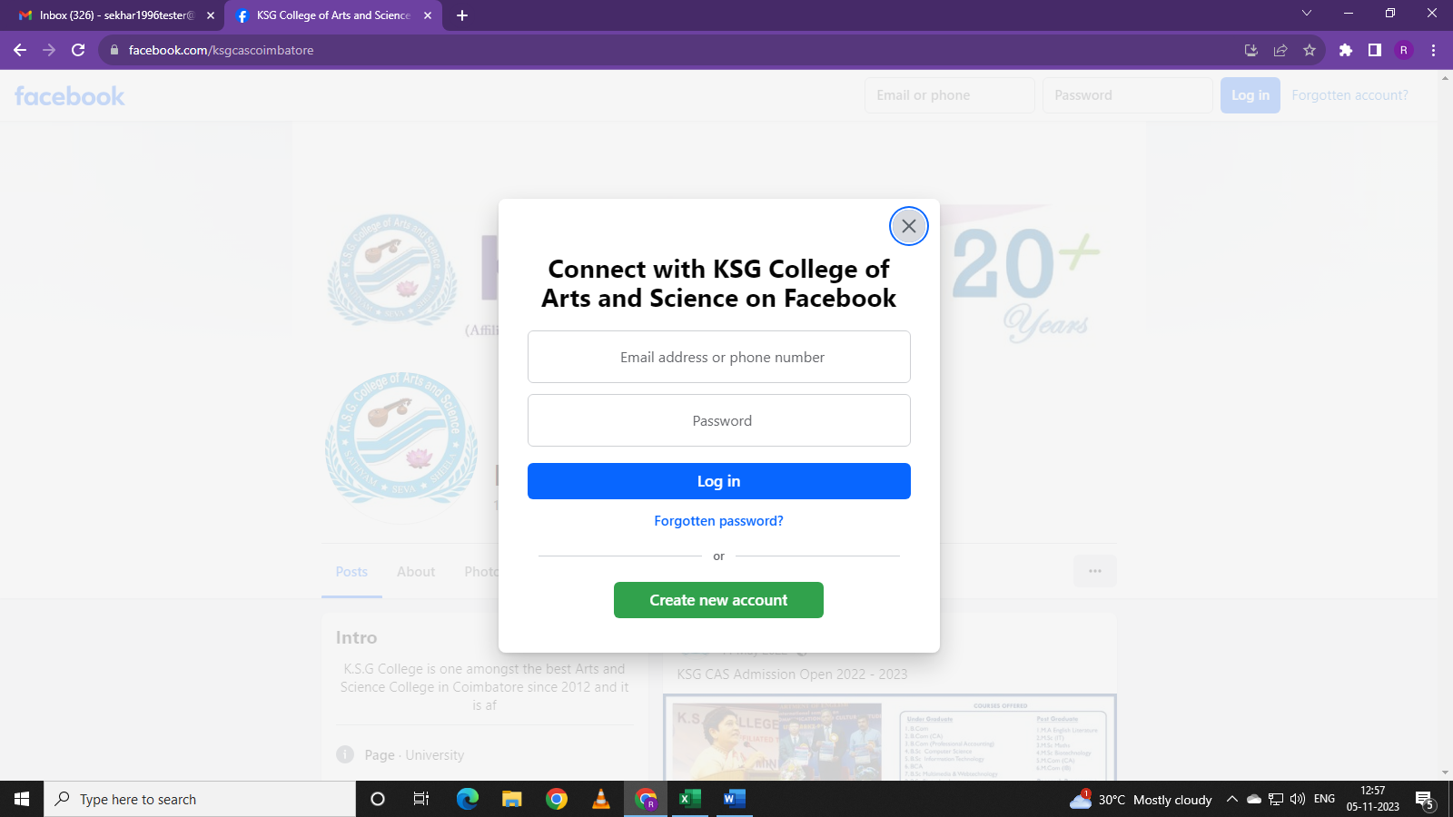

It is navigated to Facebook page.

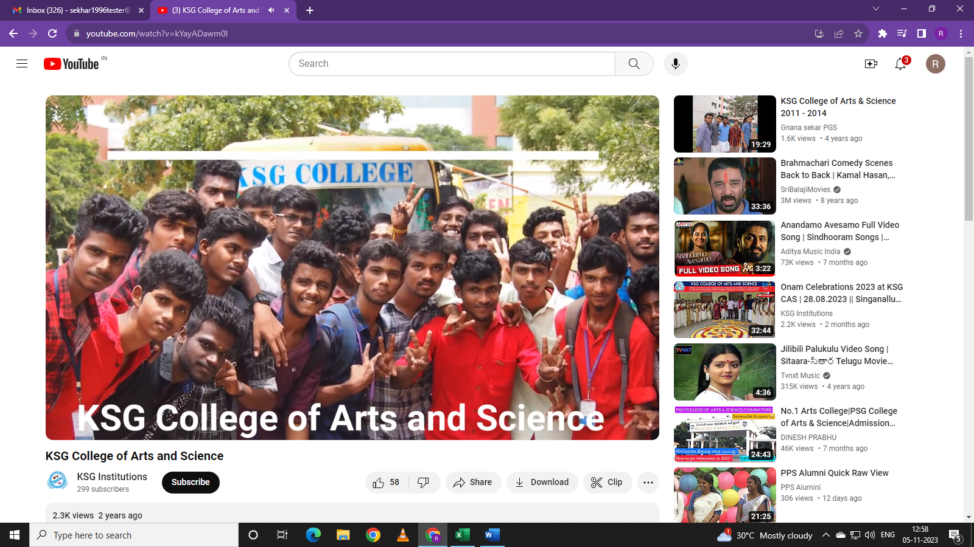

It is navigated to You tube page.

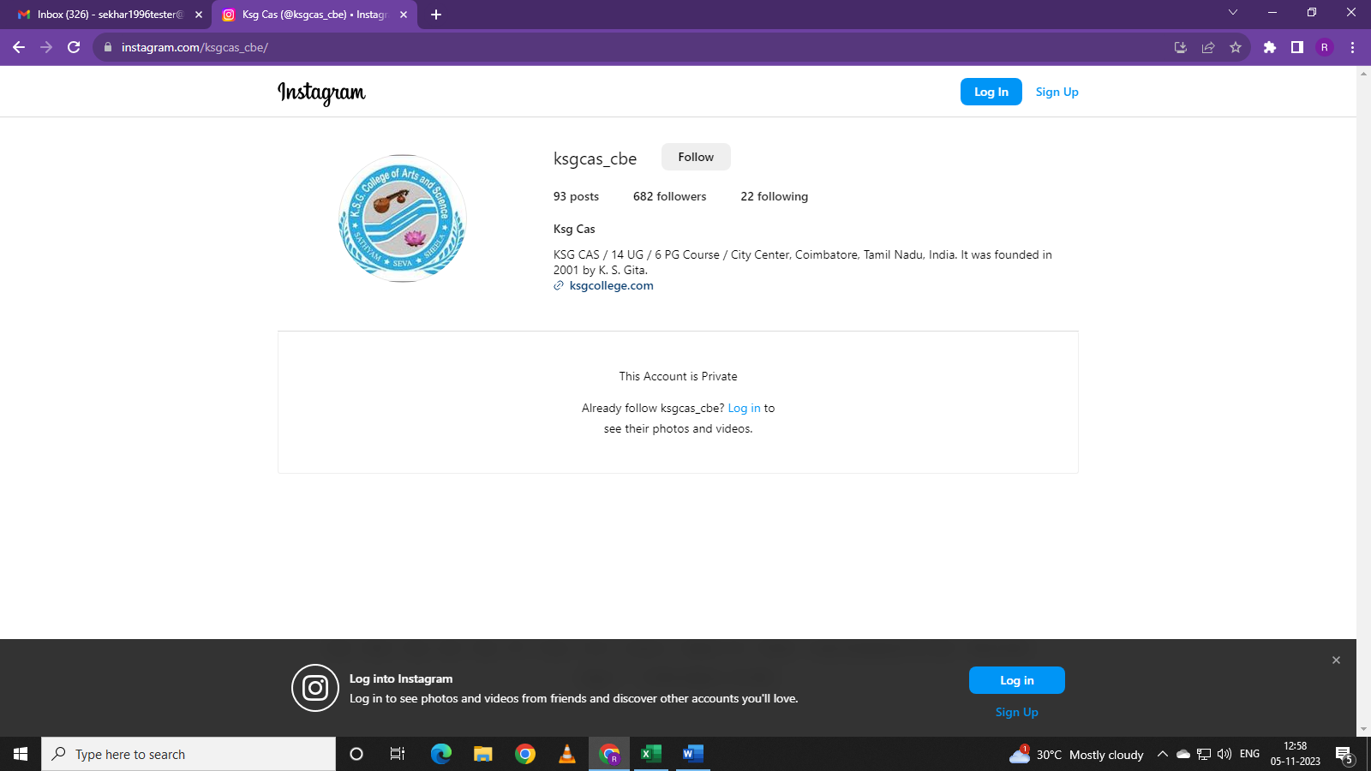

It is navigated to twitter page.

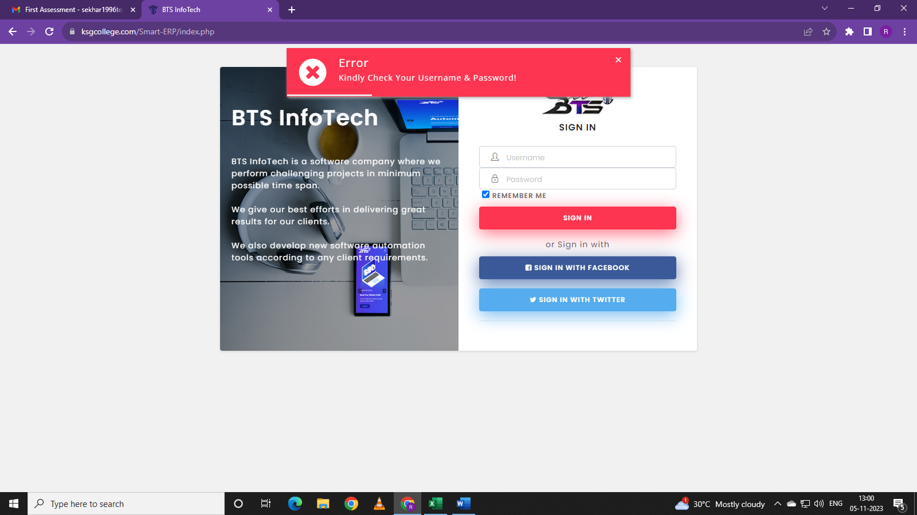

If we enter invalid detail or empty inputs in username and password inputs. It error is displayed.

But Sign in with Facebook and Twitter buttons are not working.

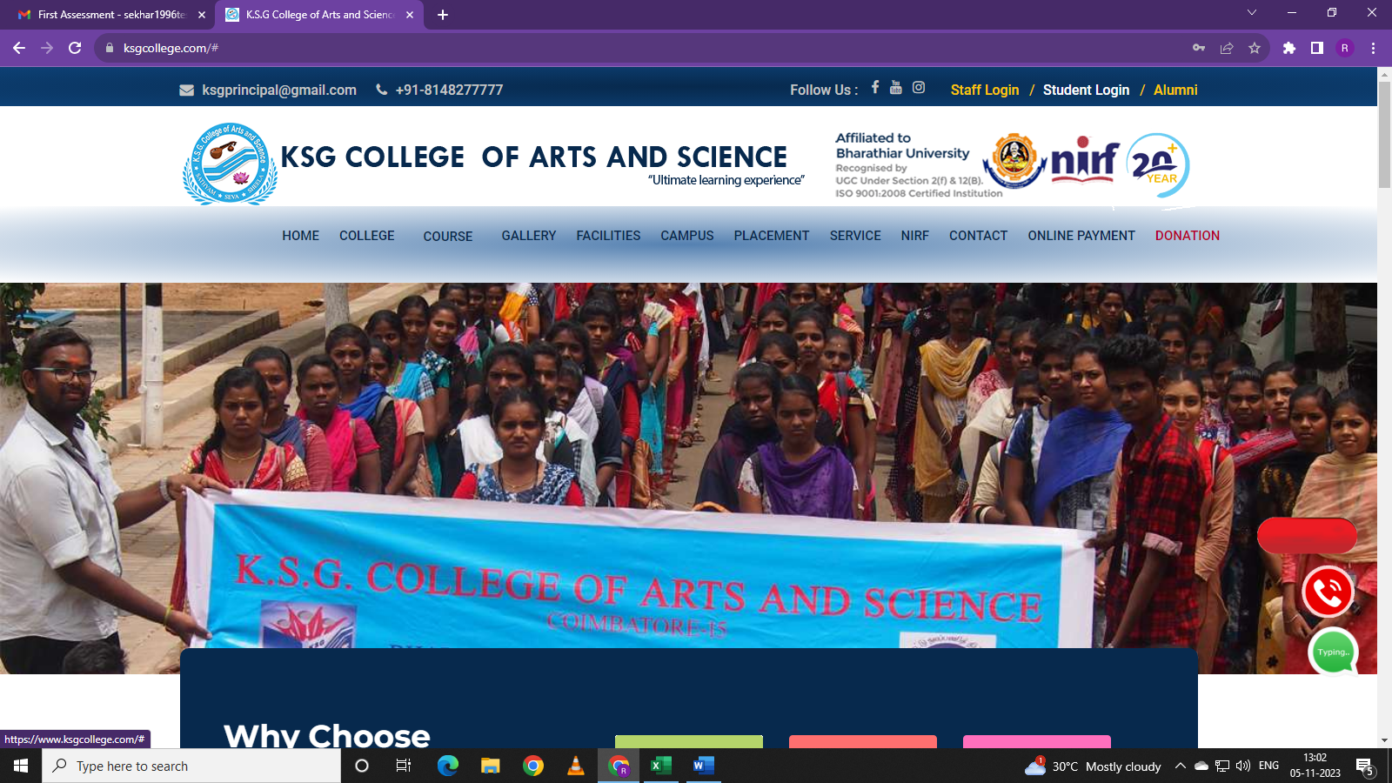

Navigate to student login and click on student login. But Not navigating to student login page.

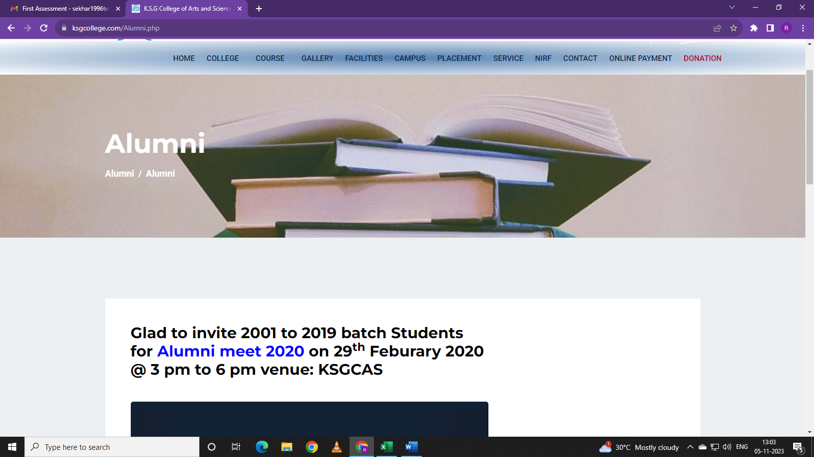

1. Navigate to Alumni. 2. Click on Alumni. It is navigated to Alumni Page. Alumni page is displayed.

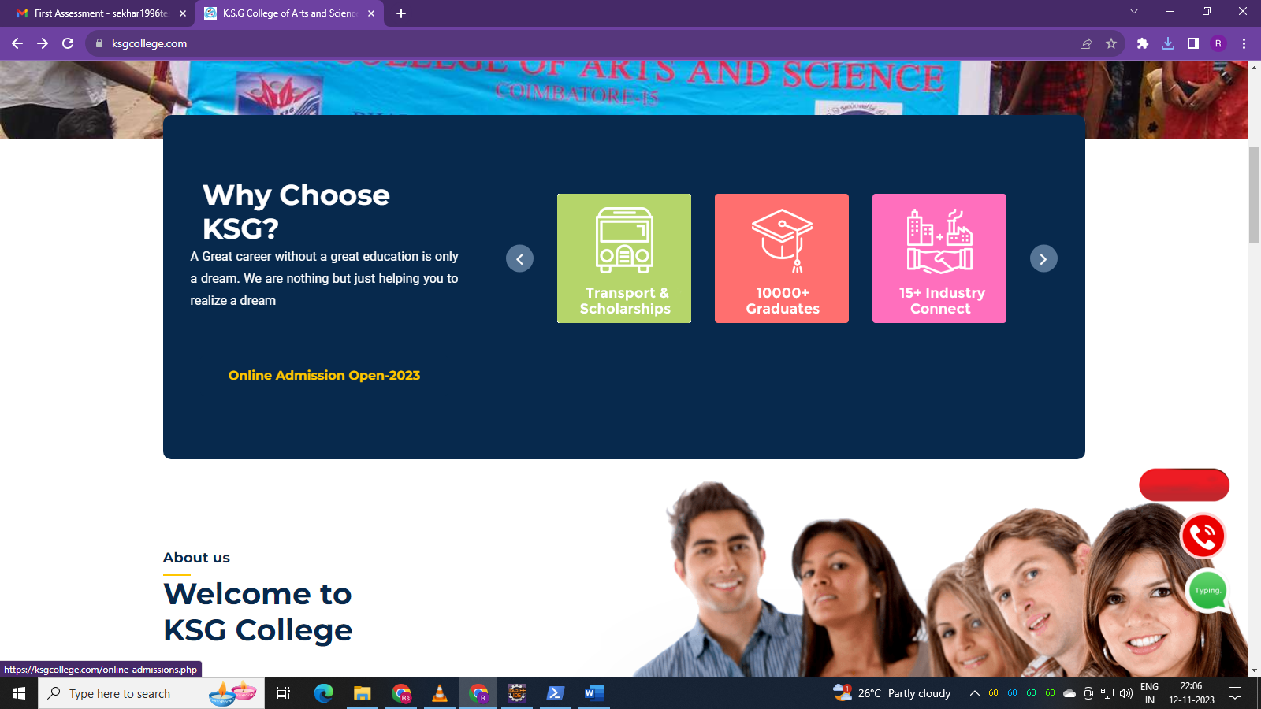

Navigate to Online Admission Open 2023 and click it. It navigate to <https://ksgcollege.com/online-admissions.php> . Online Admission form for registration.

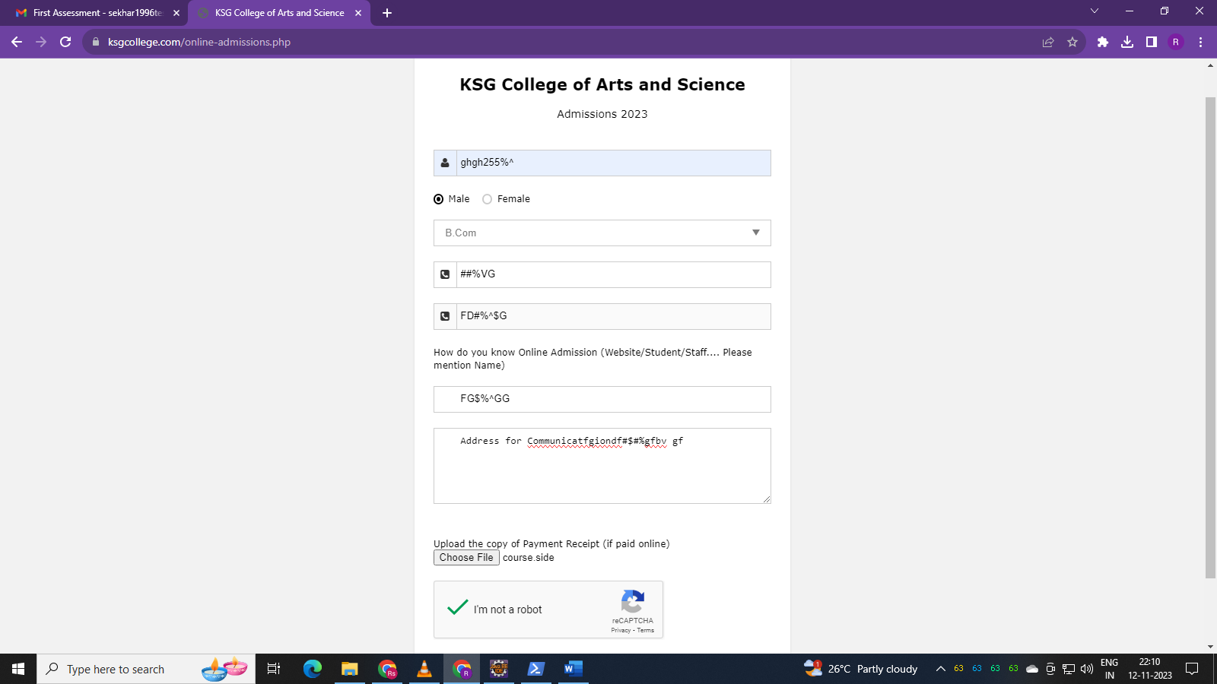

Invalid Inputs are accepted by Name, phone number, alternate number, person name.

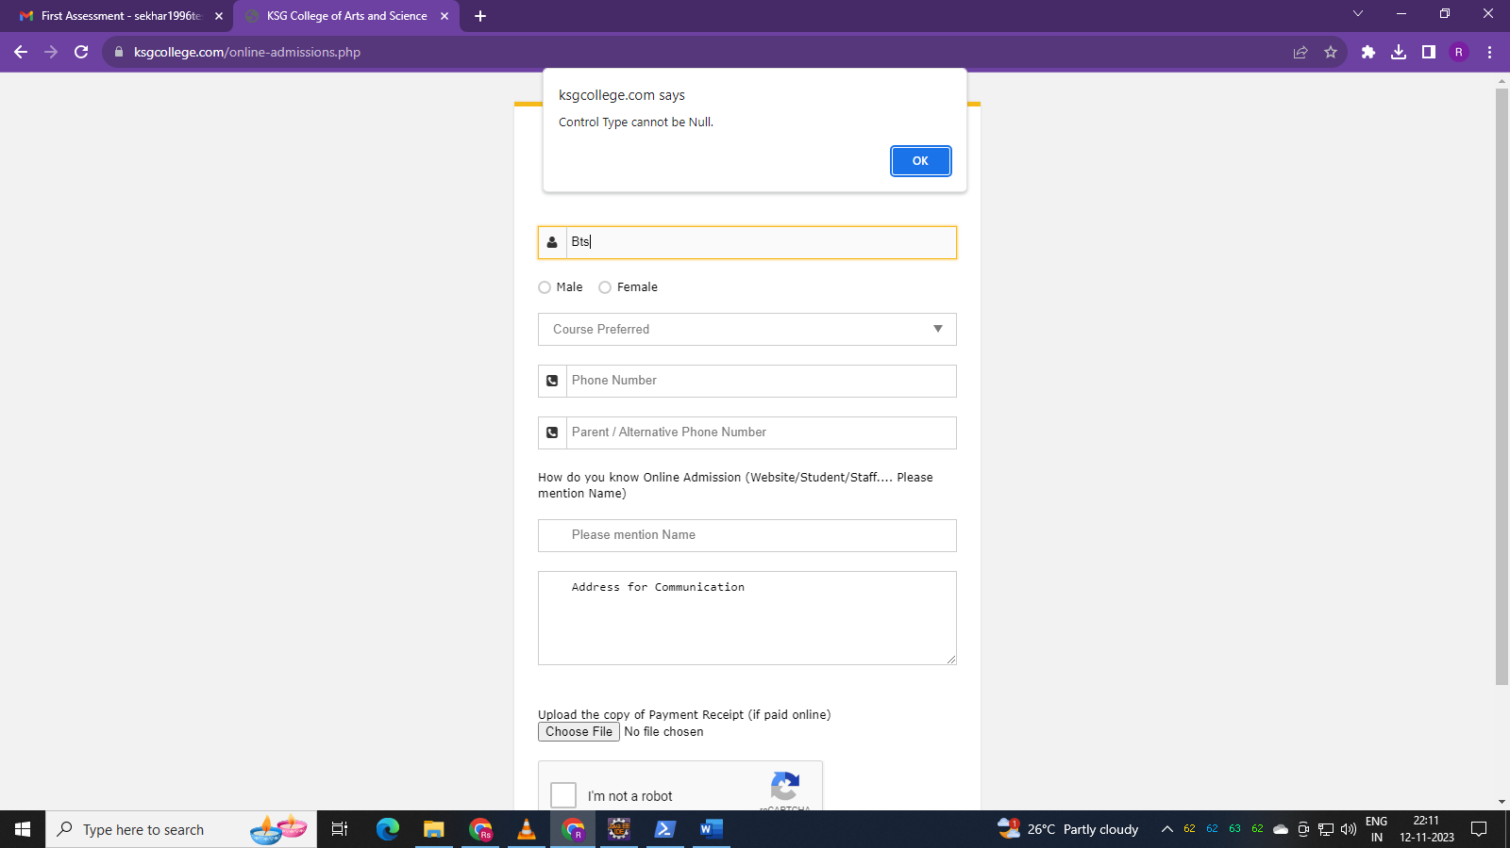

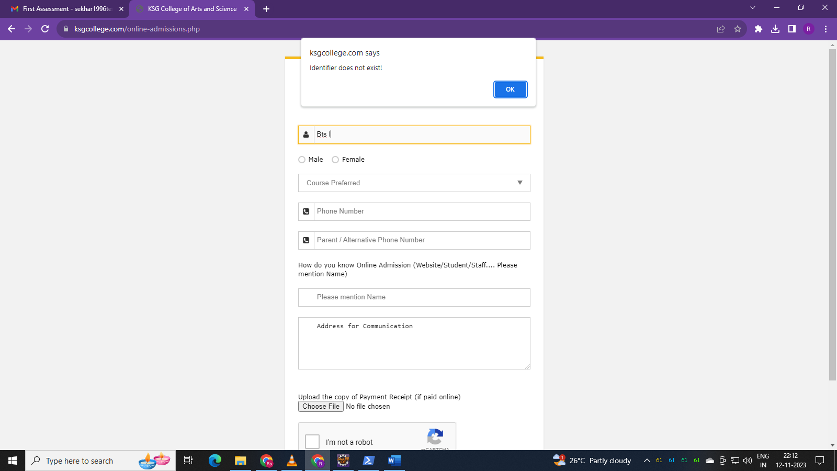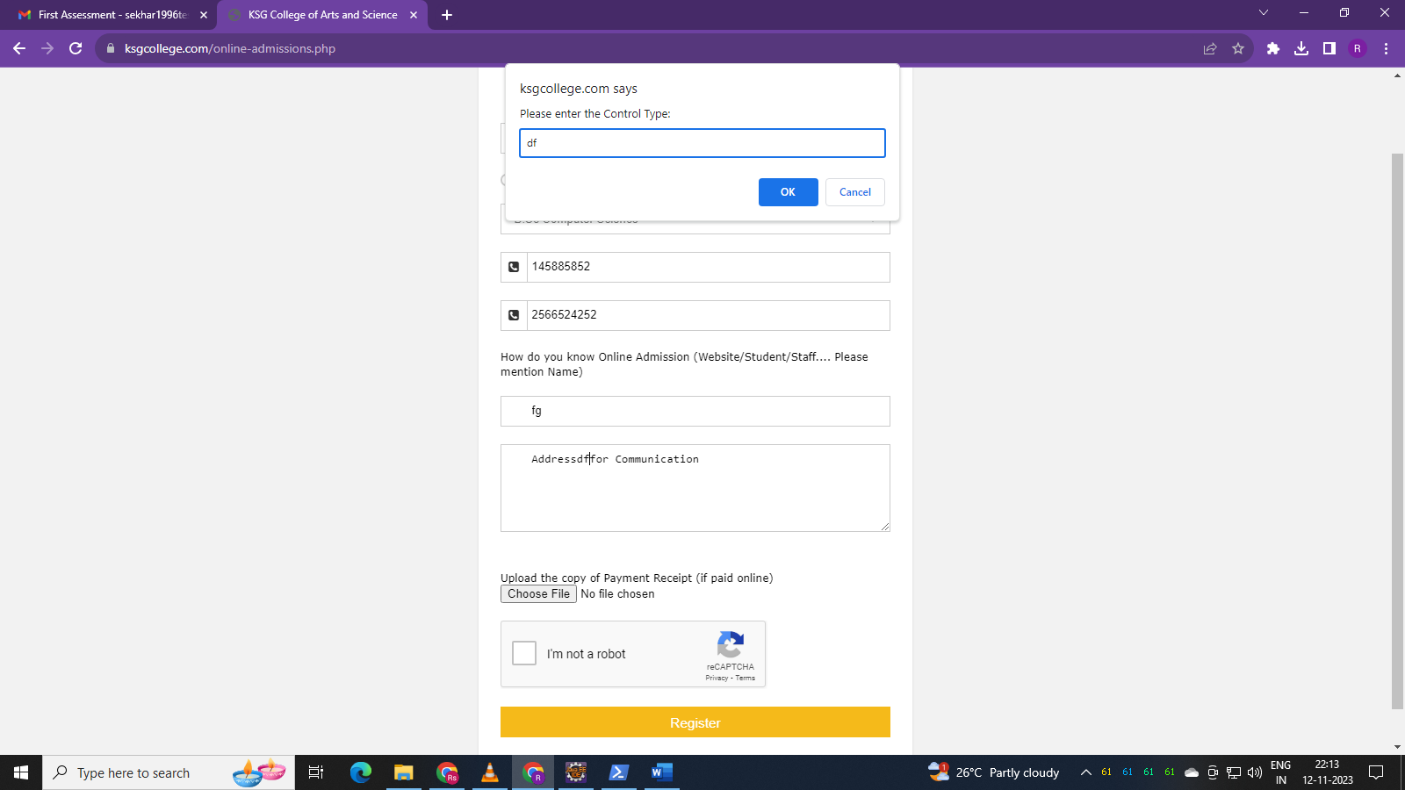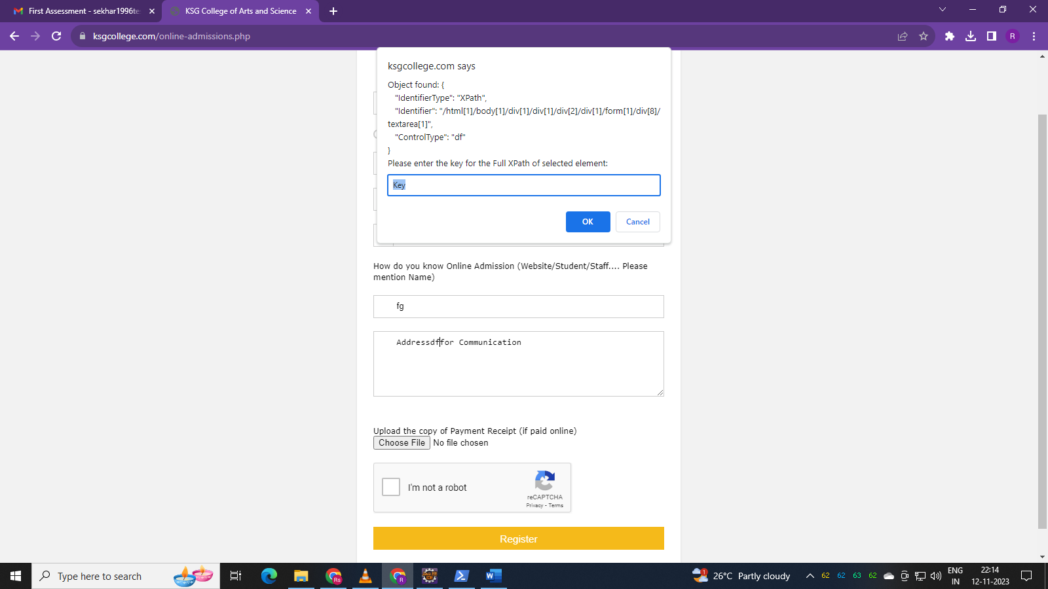

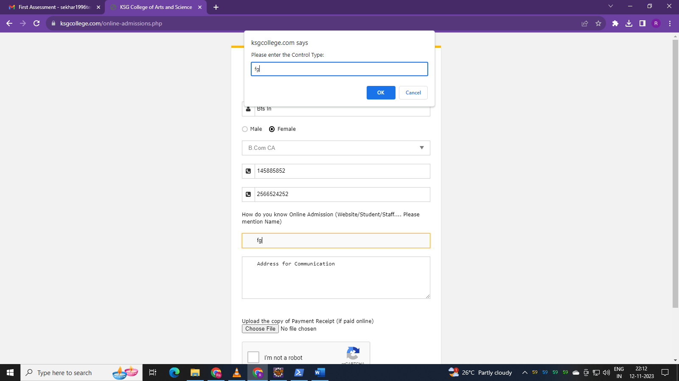

Unnecessary alerts coming when entering Name and person name and address details.

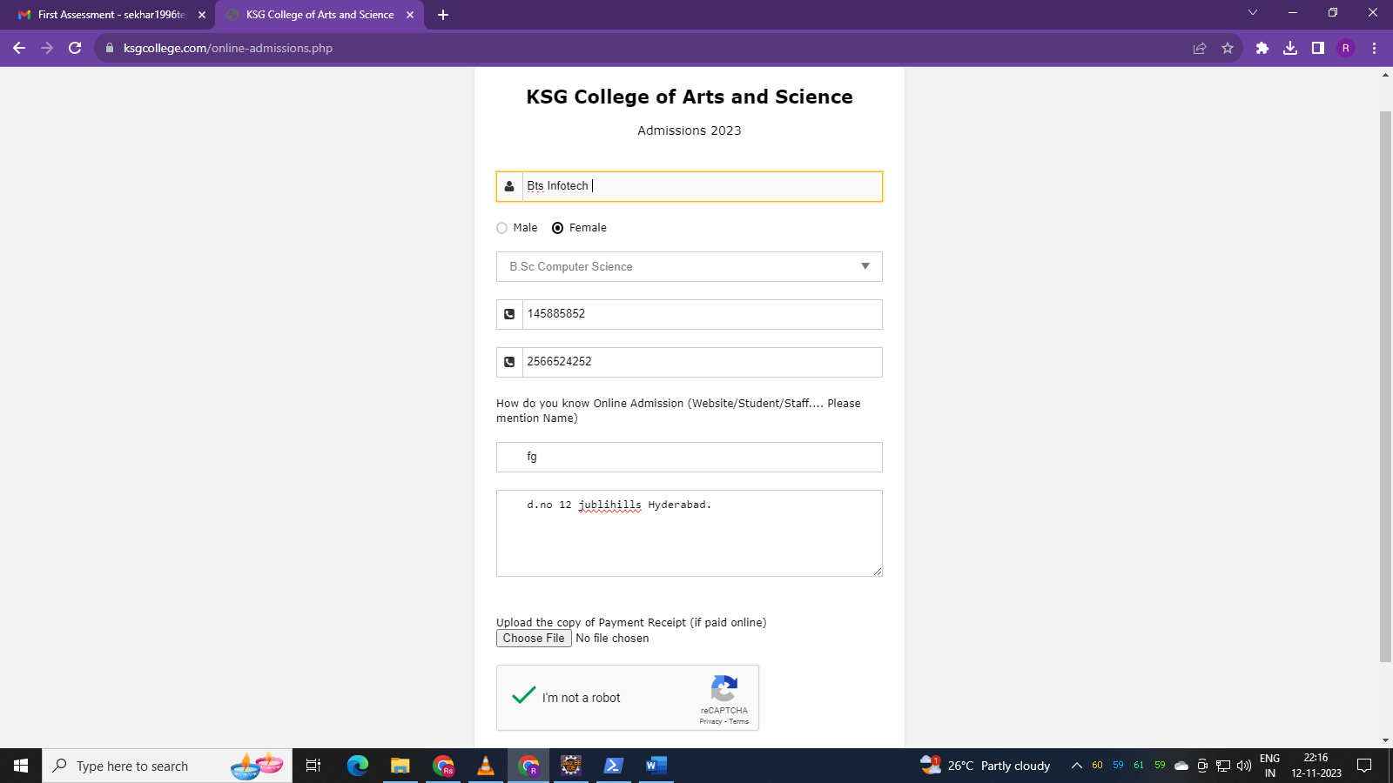

Valid Inputs Accepted by Online Registration Form.